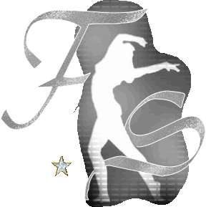
You and I both

Chor : Francien Sittrop (Jan. 2011)
Level : Easy Intermediate
Counts : 32 Counts + Tag + Restart
Walls : 4 Wall Line dance, BPM 105
Music : Dean Saunders – You and I Both, Itunes Available
Intro : Start on Vocals
Website : www.franciensittrop.nl

1 – 8 Side, Cross Rock, Coaster Step, ¼ Turn R, Cross Shuffle
1 Step R to R side (Diag Fwd)
2 – 3 Cross Rock L over R, Recover on R
4 & 5 Step L back, Step R next to L , Step L fwd
6 ¼ Turn R (03.00)
7 & 8 Step L across R, Step R to R side, Step L across R

9-16 Hip Sways , Coaster Step, Step Fwd, Pivot ½ Turn, Triple Full Turn R
1 – 2 Step R to R side and sway hips, Recover on L and sway hips L
3 & 4 Step R back, Step L next to R, Step R fwd
5 – 6 Step L fwd, Pivot ½ Turn R (09.00)
7 & 8 Triple Full Turn R with L, R,L

17-24 Rock , Recover, Lock Step Back, Sailor ¼ Turn L, Mambo ¼ Turn L
1 – 2 Rock R fwd, Recover on L
3 & 4 Step R back, Lock L across R, Step R back
5 & 6 Sweep L behind R with ¼ Turn L, Step R to R side , Step L fwd (06.00)
7 & 8 Rock R fwd, Recover on L, ¼ Turn L Step R back (03.00)

25-32 Sailor ¼ l, Rock Recover, 1 ¼ Turn R, Cross Shuffle
1 & 2 Sweep L behind R with ¼ Turn L , Step R to R side, Step L fwd (12.00)
3 – 4 Rock R fwd, Recover on L
5 & 6 ½ Turn R step R fwd, ½ Turn R step L back, ¼ R step R to R side (03.00)
7 & 8 Step L across R , Step R to R side, Step L across R

Start again:

Tag after wall 3 & 5
1 – 8 Side Rock Recover (Hip sways ). Behind Side Cross x2
1 – 2 Rock R to R side, Recover on L
3 & 4 Step R behind L, Step L to L side, Step R across L
5 – 6 Rock L to L side, Recover on R
7 & 8 Step L behind R, Step R to R side, Step L across R

Restart:
During wall 6 after count16 (Facing the front wall). Start again with count 1

