THE WATERING HOLE
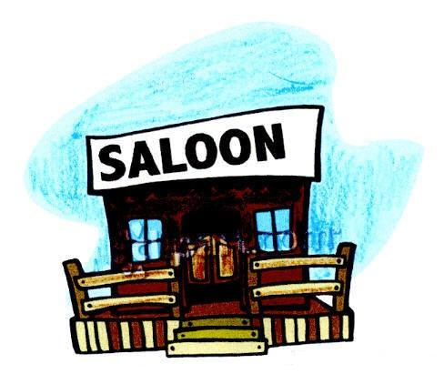

Choreographed by: Harlan Curtis - June 6, 2009
E-Mail: hccurtis@roadrunner.com
Diamond Bar, California, USA
Description: 32 count, 4 wall, Beginner Line Dance with easy 16 count tag
Music: “The Watering Hole” by Gord Bamford
2009 CCMA (Canada Country Music Association) Top new male singer
East Coast Swing Rhythm (140 BPM)
CD Album: Life Is Good, CD Label: Royalty Records Inc., Released 2008
Music is available on the artist’s web site, iTunes and CD Universe.

Start dance on vocals, 20 counts in.
Counts Step Descriptions
TOE STRUT, TOE STRUT, ROCKING CHAIR
1-2 Step left toe forward, drop left heel
3-4 Step right toe forward, drop right heel
5-6 Rock left forward, recover on right
7-8 Rock left back, recover on right 12:00

STEP, LOCK, STEP, LOCK, STEP, BRUSH, STEP FORWARD, STEP 1/4 TURN LEFT
1-2 Step forward on left, lock right behind left
3-4 Step forward on left, lock right behind left
5-6 Step forward on left, brush right
7-8 Step forward on right, step 1/4 turn on left to left 9:00

WEAVE LEFT, CROSS , RECOVER, STEP SIDE, STEP TOGETHER
1-2 Cross right over left, step left to left side
3-4 Cross right behind left, step left to left side
5-6 Cross right over left, recover on left
7-8 Step right to side, step left next to right (WOL) 9:00

HEEL, HOOK, HEEL, FLICK, STEP TOGETHER , STEP, TOUCH
1-2 Touch right heel forward, hook right foot over left foot
3-4 Touch right heel forward, flick right foot diagonally back to the right
5-6 Step forward on right, close left next to right (optional stomp for count 6)
7-8 Step forward on right, touch left next to right 9:00

REPEAT

TAG
At the start of the 5th wall (12:00), add the following 16 counts

TOE STRUT, TOE STRUT, ROCKING CHAIR
1-2 Step left toe forward, drop left heel
3-4 Step right toe forward, drop right heel
5-6 Rock left forward, recover on right
7-8 Rock left back, recover on right 12:00

STEP, LOCK, STEP, LOCK, STEP, BRUSH, STEP FORWARD & HOLD, CLAP
1-2 Step forward on left, lock right behind left
3-4 Step forward on left, lock right behind left
5-6 Step forward on left, brush right
7-8 Step forward on right and hold, clap (WOR) 12:00

RESTART DANCE AGAIN FROM THE BEGINNING

