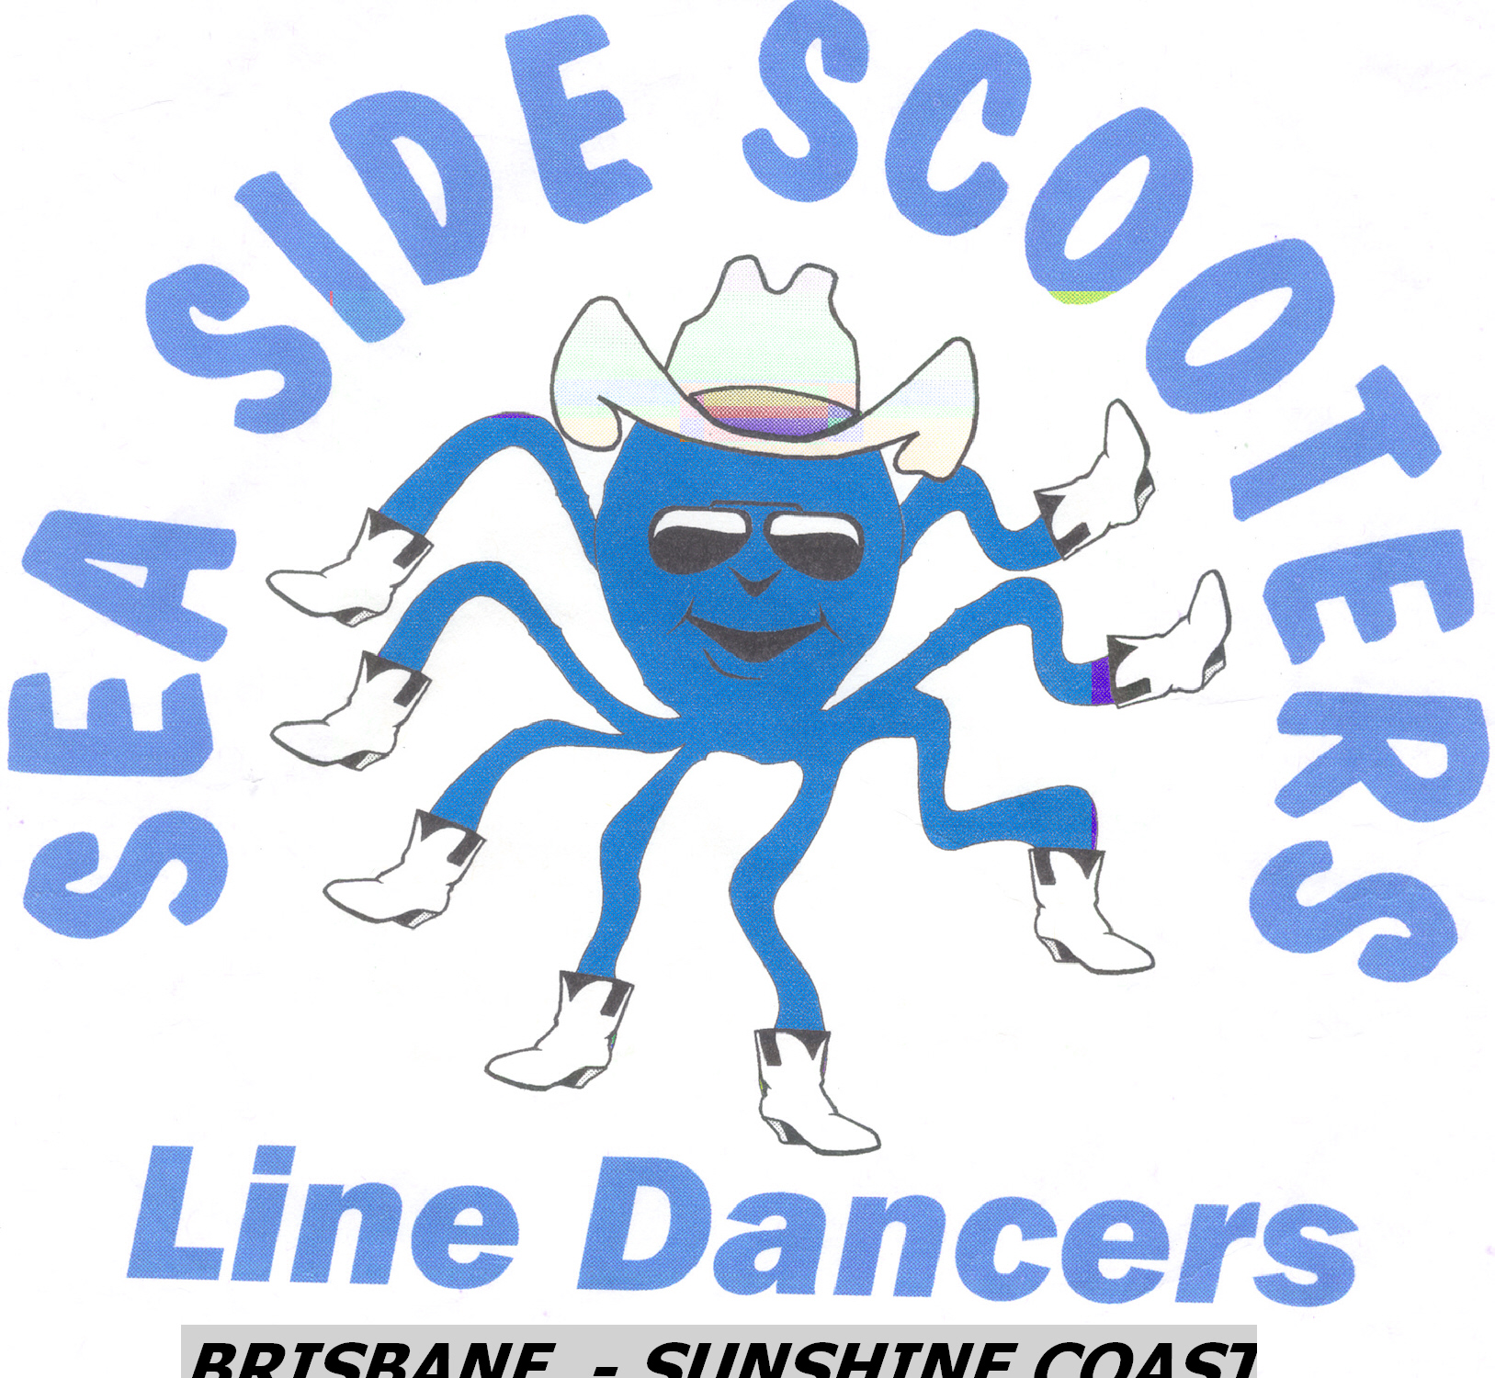

The Waltz of Erin
Song : Pride of Erin Album :- Prodical Son
Artist : Luke O’Shea
Choreographed By : Delwyn Swaisland , Qld ,Australia
(07) 3348 6848 Mob.04107 83636
Email : delwynsss@westnet.com.au

66 Count 2 Wall Waltz Line Dance Intermediate
Count Steps

FWD, FWD, RECOVER, BACK, ¼ LEFT, CROSS
1 2 3 Step fwd L, rock fwd on R, recover back on L
4 5 6 Step back R, ¼ left on L, cross R over L
ROCK L& HOLD, ROCK R & HOLD
7 8 9 Step / rock left side on L, hold (2 beats)
10 11 12 Step / rock right side on R, hold (2 beats)
¼ L , ROCK ,ROCK , ROCK , ROCK , ½ RIGHT
1 2 3 Turning ¼ left step fwd on L, rock fwd on R, recover on L
4 5 6 Rock fwd on R, recover on L, turning ½ right step fwd on R
FULL TURN , ROCK x 3
7 8 9 Full turn fwd turning right (LRL)
10 11 12 Rock fwd on R, recover on L, rock fwd on R
CROSS , POINT , HOLD ,BACK , ½ L , ¼ L
1 2 3 Cross step L over R, point R to right side , hold
4 5 6 Step back on R, turn ½ left step fwd on L, turn ¼ left step side on R
L SAILOR , R SAILOR
7 8 9 Step L behind R, rock R to right side , recover on L
10 11 12 Step R behind L, rock L to left side , recover on R
BEHIND , ¼ R , FWD , ROCK x 3
1 2 3 Step L behind R, turning ¼ right step fwd on R, step fwd on L
4 5 6 Rock fwd on R, recover on L, rock fwd on R
FWD , SLOW ½ PIVOT , R COASTER
7 8 9 Step fwd on L, slow ½ turn right ( 2 beats -weight on L)
10 11 12 Step R back , step L next to R, step fwd on R
L LOCK STEP , SLOW ½ PIVOT L
1 2 3 Step fwd on L, R behind L, Fwd on L
4 5 6 Fwd on R, ½ turn left (2 beats - weight on R)
LEFT COASTER , R LOCK STEP
7 8 9 Step back on L, R next to L , fwd on L
10 11 12 Step fwd on R, L behind R , fwd on R ***
FWD L , DRAG 2 ,BACK R , DRAG 2
1 2 3 Step fwd on L, drag R to L (2 beats) ,
4 5 6 Step back on R, drag L to R (2 beats)

*** Walls 2 & 4 are short walls – dance 60 steps & restart from beginning.

I love this song to bits. I, for one can remember “The Pride of Erin”, can you ?
Keep smiling & Enjoy !

