WHAT’S  THE  DEAL? | 64 Count - 2 Wall – High Intermediate Level  Choreographed to ‘Nobody’ By Ne-Yo  Choreographed By Craig Bennett, Dee Musk & Shaz Walton  September 2008  Count in 32- on vocals. BPM 124  **1 restart during wall 2 – count 32 facing 12 o’clock** | 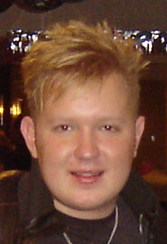 |  | 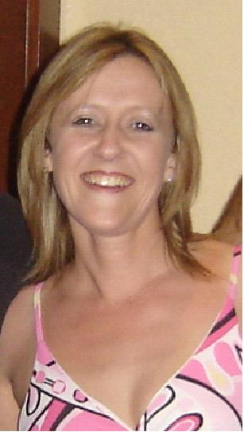
Ball Cross. Point. Touch. Point. Touch. Hitch. Side push. Recover.
&1-2 Step left beside right. Cross right over left. Point left to left side.
3-4 Cross touch left over right. Touch left to left side.
5-6 Touch left beside right. Hitch left up.
7-8 Touch left to left side as you push over on left hip. Recover weight on right as you push to right. 12 o’clock

Ball cross. Hold. Ball cross. Ball cross. Push. ½ walk.
&1-2 Step left beside right. Cross step right over left. Hold.
&3&4 Step left beside right. Cross step right over left. Step left beside right. Cross step right over left
(Keep steps tight & roll hips anti clockwise to add a little styling ☺ )
5 Step left Pushing left hip to left side.
6-7-8 Walk ½ turn right stepping Right- left- right. 6 o’clock

½ spin right. Hold. Ball heel. Ball touch. Ball heel. Ball touch. Hitch. Step drag. Touch
1-2 On ball of right make a sharp ½ spin finishing with weight on left. Hold.
&3&4 Step right beside left. Touch left heel forward. Step left beside right. Touch right beside left.
&5&6 Step right beside left. Touch left heel forward. Step left beside right. Touch right beside left.
&7-8 Hitch right knee. Step right large step right dragging left to right. Touch left beside right. 12 o’clock

Ball step. Lock. ½ ball step. Touch. Back step touch x 3. Out. Out.
&1-2 Step left beside right. Step right forward. Lock left behind right as you start to make ½ turn left.
&3-4 Complete ½ left as you step back right. Step forward left. Touch right beside left.
&5&6 Step back small step right. Touch left slightly forward. Step back small step left. Touch right slightly forward.
&7&8 Step back small right. Touch left slightly forward. Step left to left. Step right to right. **Restart here wall 2 – facing
12 o’clock** (Harder option – replace counts &5&6&7 with Batchachara) 6 o’clock

Ball cross. Side. Hook. ½ box left. Sailor ¼ left. Sailor step.
&1-2 Step left beside right. Cross right over left. Step left to left as you hook right up into a figure 4
3-4-5 Step right to right. Step left ¼ turn left. Step right ¼ turn left.
6&7 Cross left behind right. Step right ¼ turn left. Step left to left side
8&1 Cross step right behind right. Step left to left. Step right to right. 9 o’clock

Hold. Ball side. Ball side. Ball flick. Flick. Cross. Step. Cross.
2 Hold
&3&4 Step left beside right. Step right to right. Step left beside right. Step right to right.
&5-6 Step left beside right. Step right beside left as you flick left to left side. Step left beside right as you flick right to right. (Pendulum kick)
7&8 Cross step right over left. Step left to left. Cross step right over left. 9 o’clock

¼ right. ½ right. ½ right chase turn. Lock step. Out. Out.
1-2 Make ¼ turn right stepping back left. Make ½ turn right stepping right forward.
3&4 Step forward left. Make ½ turn right stepping right forward. Step forward left.
5-6-7 Lock right behind left. Step left forward. Lock right behind left.
&8 Step left to left side. Step right to right side. 12 o’clock

4 Count Roll. Ball Cross. Point. ½ turn right. Point.
1-2-3-4 Over 4 counts roll your hips clockwise. (Weight ends left)
&5 Step right beside left. Cross left over right.
    - Point right to right side. On ball of right make ½ turn right stepping right beside left.
Point left to left side. 6 o’clock
Begin again & Smile ☺

- Craig – www.craigbennett.co.uk - Craig_b69@msn.com
- Dee –www.deemusk.com - deemusk@btinternet.com
- Shaz – Shaz5678@sky.com

