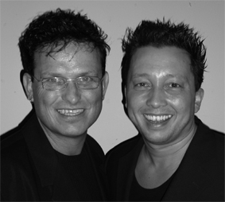
What They Say

Choreographers : Roy Verdonk and Wil Bos (feb 2010)
Level : Easy intermediate
Dance : 4 wall, 32 counts + 1 Tag during wall 5 + Restart
Music : Michael Peterson – That’s what they said about the buffalo
Intro : 32 counts

Step, Rock, Recover, Shuffle forward, Cross, Side, Cross, Back, Side, Cross
1-2-3 Step left to left side, Cross rock right behind left, Recover L (facing 01:30)
4&5 Step right forward to right diagonal, Close left next to right, Step right forward to right diagonal (01:30)
6&7 Cross left over right, Step right to right side, Cross left behind right (facing 10:30)
8&1 Step right back (stay on diagonal), Step left to left side (09:00), Step right forward (facing 07:30)

Step, Side, ¼ Turn, Back, ½ Turn, Rock, Recover, Back Lock Step
2&3 Step left forward (07:30), Step right to right side (06:00) ¼ turn left step left back
4&5 Step right back, ½ turn left step left forward, Step right forward (09:00)
  - Rock left forward, Recover R **** (In wall 5 Tag and Restart)
8&1 Step left back, Cross right over left, Step left back

¼ Turn Rock, ¼ Turn Recover, Full Turn, Step, Pivot, Step, Forward Lock Step L
2-3 ¼ turn right rock right to right side (12:00), Recover with ¼ turn left (09:00)
4&5 ½ turn left step right back, ½ turn left step left forward, Step right forward
6-7 ½ turn left, Step right forward
8&1 Step left forward, Cross right behind left, Step left forward

Sweep, Cross, Rhumba Box L, Rhumba Box R, Step, ¾ Turn R
2-3 Sweep right from back to front with ¼ turn left, Cross right over left (12:00)
4&5 Step left to left side, Close right next to left, Step left forward
6&7 Step right to right side, Close left next to right, Step right forward
8& Step left forward, ¾ turn left step left to left side for 1 (09:00)

Tag + Restart
*** In wall 5 you dance up to count 6-7 Rock, Recover in section 2 and replace count 8&1 Back lock step
in to a left sailor step, and you restart the dance on count 1 on the 9 o’ clock wall.

Start again and let the music touch your soul

