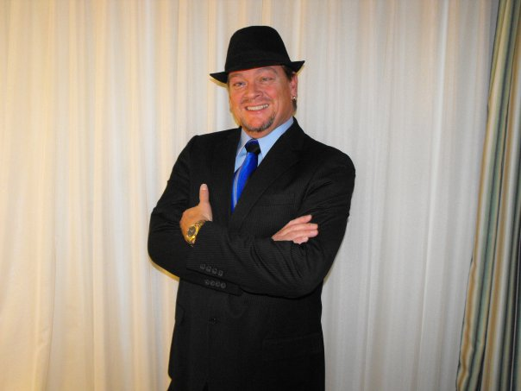
They Try

48 Count 4 Wall, Intermediate/Advance
32 Count Intro, CW Rotation, International Cha Cha Rhythym
8 Count bridge after wall 2, 2 count hold after wall 5
Choreographed By: Steve Lescarbeau, Feb. 2011
Music, “They Try” By Rascal Flatts
steve@aplusvacations.com

Count Call/Description Wall

1 – 9 Tap, Step, Tap, Step, Weave Cross Rock, Recover, ¼ R, ½ R, ½ R Cross

&1, 2, 3, 4 & Tap R toe next to L, Step on R, Tap L toe next to R, Step L, Step R behind L, Quickly step L
5, 6, 7, 8 &1 Cross Rock R over L, Recover, Step ¼ R, Turning ½ R step back on L, Turning ½ R
Step forward R, Cross Rock L over R 3:00

10 – 17 Recover, Step Back, R Anchor Step, Step Forward, ½ L, ¼ L Shuffle

2, 3, 4 &5 Recover R, Step Back on L, Rock back on R, Quickly recover L, Step back on R
6, 7, 8 &1 Step forward on L, Turning ½ L step back on R, Turning ¼ L shuffle forward, L R L 6:00

18 – 25 Cross, Back, Back Lock Step, Rock Back, Recover, Scissor ¼ R

2, 3, 4 &5 Cross R over L, Step back L, Step back R, Slide L across and back, Step back R
6, 7, 8 &1 Rock back L, Recover R, Step forward L, Quickly step R ¼ R, Cross L over R 9:00

26 – 33 Walk, Walk, Rock Recover ½ R, ½ R, ½ R, Rock Recover Back

2, 3, 4 &5 Walk forward R, Walk forward L, Rock forward R, Quickly recover L, Step ½ R forward
6, 7, 8 &1 Turning ½ R step back on L, Continue turning ½ R stepping forward on R, Rock forward L,
Quickly recover R, Step back L 3:00

33 – 41 Back, Back, Mambo Step, Paddle ¼ R, Paddle ¼ R, Kick Across Ball Touch

2, 3, 4 &5 Step back R, Step Back L, Rock back R, Quickly recover L, Step R home
6, 7, As you make a ¼ R on ball or R point L to L, As you make a ¼ R on ball of R point L to L,
8 &1 Kick L to R across R, Quickly step on L, Touch R home 9:00

42 – 48 Kick R Forward, Kick R to R, Sailor ½ R, Twist ½ L, Twist ½ R, Step L

2, 3, 4 &5 Kick R forward, Kick R to R, Swing your R ½ to R stepping on R, Quickly Step on L, Step R
6, 7, 8 On balls of both feet twist ½ L, On balls of both feet twist ½ R, Step L to L 9:00

Begin Again! Enjoy!

BRIDGE After wall 2 (facing 6:00) there is an 8 count bridge as follows, then restart from &1

Tap, Step, Tap, Rolling Vine w/Cross Rock, Recover, ½ R, ½ R
&1, 2, 3, 4 & Tap R toe next to L, Step on R, Tap L toe next to R, Step L ¼ L, ½ L stepping back on R,
5. 6. 7. 8 Cross Rock R over L, Recover L, ½ R stepping R, Continue turning ½ R stepping L to L Restart

HOLD for 2 beats after wall 5 (3:00) and begin again. (I like to drag my R to my L for 2 beats)
www.LineDancersSpringBreak.com www.aplusvacations.com

