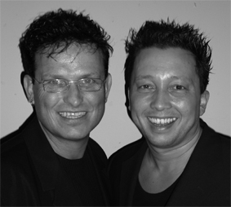
Too Many Tears

Choreographers : Wil Bos and Roy Verdonk
Level : Improver
Dance : 32 counts + 1 easy Tag
Music : Sabina – 9.999.999 tears
Intro : 16 counts

Side, Close, Side Shuffle ¼ Turn, Step, ¼ Turn, Cross Shuffle

1-2 Step right to right side, Step left next to right
3&4 Step right to right side, Step left next to right, ¼ turn right step right forward
5-6 Step left forward, ¼ turn right
7&8 Cross left over right, Step right to right side, Cross left over right

Side, Close, Coaster Cross, Side, Close, Coaster Step

1-2 Step right to right side, Step left next to right
3&4 Step back on right, Step left next to right, Cross right over left
5-6 Step left to left side, Step right next to left
7&8 Step back on left, Step right next to left, Step left forward

Rock, Recover, ½ Turn Shuffle, Step, Pivot Hook, Shuffle Forward

1-2 Rock right forward, Recover
3&4 ¼ turn right step right to right side, Step left next to right, ¼ turn right step right forward
5-6 Step forward on left, ½ Turn right and raise right foot (heel) in front of left shin.
7&8 Step forward on right, Step left next to right, Step forward on right

Rock, Recover, Coaster Step, ¼ Monterey Turn

1-2 Rock left forward, Recover
3&4 Step left back, Step right next to left, Step left forward
  - Point right to right side, ¼ Turn right step right next to left
  - Point left to left side, Step left next to right

Start again and let the music touch your soul

TAG – Happens after wall 3 and wall 7

Jazz Box (x2), Cross Rock

    - Cross right over left, Step left back, Step right to right side
    - Cross left over right, Step right back, Step left to left side
  - Cross Rock right over left, Recover

