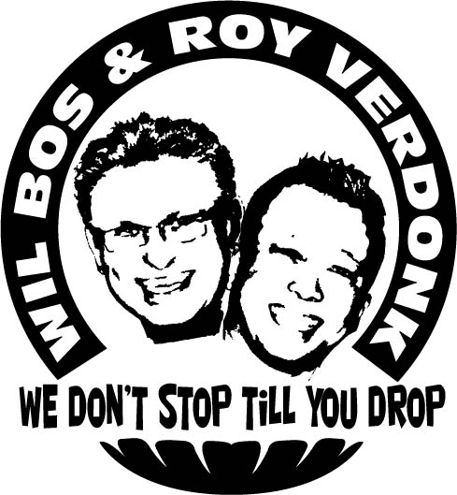
Superstar

Choreographers : Wil Bos & Roy Verdonk
Level : Medium intermediate
Dance : 64 counts, 4 wall, 1 Restart
Music : DJ Bobo – Superstar, CD Superstar
Info: : Restart during wall 3.
Intro : 16 counts

Side Shuffle R, Behind Side Cross, Side Recover Cross, ¼ Turn R, ¼ Turn R, Cross L
1&2 Step right to right side, Close left next to right, Step right to right side
3&4 Cross left behind right, Step right to right side, Cross left over right
5&6 Rock right to right side, Recover on left, Cross right over left
7&8 ¼ turn right step left back, ¼ turn right step right to right side, Cross left over right (6.00)

Side Rock R, Recover L, Close, Side Rock L, Recover R, Sailor ¼ Turn L, Right Shuffle Forward
1-2& Rock right to right side, Recover on left , Close right next to left
3-4 Rock left to left side, Recover on right
5&6 Cross left behind right, ¼ turn left step right to right side, Step left forward
7&8 Step right forward, Close left next to right, Step right forward (3.00)

Rock L, Recover R, ½ Turn Shuffle L. , Right Shuffle Forward, ½ Turn R. ¼ Turn R.
1-2 Rock left forward, Recover
3&4 ¼ turn left step left to left side, Close right next to left, ¼ turn left step left forward**
**Restart during wall 3 after count 20 (after the half turn shuffle left)
5&6 Step right forward, Close left next to right, Step right forward
7-8 ½ turn right step left back, ¼ turn right step right to right side (6.00)

Cross Side, Sailor Step L, Cross Side, Coaster Step R
1-2 Cross left over right, Step right to right side
3&4 Cross left behind right, Step to right, Step left to left side
5-6 Cross right over left, Step left to left side
7&8 Step right back, Close left next to right, Step right forward (6.00)

Rock L, Recover R, Close, Rock R Recover L, Coaster Cross R, Kick Ball Cross L
1-2& Rock left forward, Recover on right, Close left next to right
3-4 Rock right forward, Recover on left
5&6 Step right back, Close left next to right, Cross right over left
7&8 Kick left to left diagonal, Step on ball of left next to right, Cross right over left (6.00)

Kick Ball Cross L, Side Rock L, Recover R ¼ Turn R. Step L, Right Shuffle Forward, Full Turn R.
1&2 Kick left to left diagonal, Step on ball of left next to right, Cross right over left
3&4 Rock left to left side, Recover on right with ¼ turn right, Step left forward
5&6 Step right forward, Close left next to right, Step right forward
7-8 ½ turn right step left back, ½ turn right step right forward (9.00)

Rock L, Recover R, ¾ Triple Turn L, Rock R, Recover L, Out R, Out L, Step Back R
1-2 Rock left forward, Recover on right
3&4 Left triple step turning 3/4 turn left stepping left. right. Left
5-6 Rock right forward, Recover on left
&7-8 Step right out backwards, Step left to left side (feet shoulder width apart), Step right back (12.00)

Sailor Step ¼ Turn Left, Rock R, Recover L, Out R, Out L,Touch right beside left (2x)
1&2 ¼ turn left cross left behind right, Step right right side, Step left forward
3-4 Rock right forward, Recover on left
&5-6 Step right out backwards, Step left to left side (feet shoulder width apart), Touch right next to left
&7-8 Step right out backwards, Step left to left side (feet shoulder width apart), Touch right next to left (9.00)

Start again smile and have fun

