she’s country
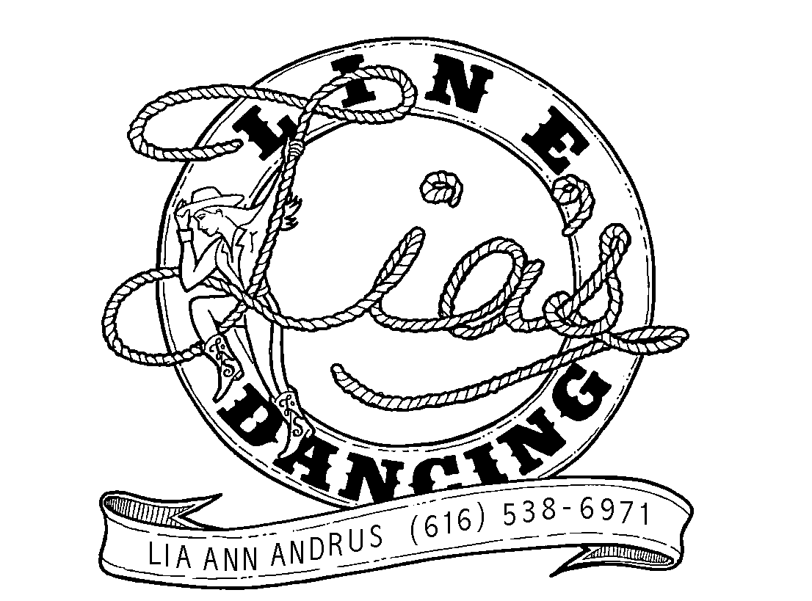

BEGINNER/intermedate PHRASED Line Dance - 4 Wall - 32 counts
CHOREOGRAPHED BY lIA aNDRUS & aL DYKSTRA
MUSIC: SHE’S COUNTRY (BY jASON ALDEAN)
Note: restart on the 3RD WALL after the first 1-8 (details at the bottom of page)
dance Starts: with the lyrics on count 64 If you want to start the dance earlier, You can start on count 32 and do the first 8 counts 4 times instead of just twice.

WALK-WALK-SLIDE, STEP-1/2 TURN-SAILOR STEP-HEEL SWIVEL 2X
1-2 STEP FORWARD RIGHT-STEP FORWARD LEFT
&3 SLIDE LEFT FOOT BACK AS YOU BRING RIGHT knee UP-STEP FORWARD RIGHT
4 TURN ½ LEFT (END WEIGHT ON RIGHT knees slightly bent, kind of a sit position)
5&6 STEP LEFT BEHIND RIGHT-STEP RIGHT TO RIGHT-STEP LEFT forward
7&8 TOUCH RIGHT TOE FORWARD SWIVELING RIGHT HEEL L-R-L

WALK-WALK-SLIDE, STEP-1/2 TURN-SAILOR STEP-HEEL SWIVEL 2X
  - REPEAT ABOVE 1-8

BIG STEP R-TOUCH-BIG STEP L W/ ¼ TURN R-TOUCH-WEAVE RIGHT WITH TOUCH
  - STEP A LARGE STEP TO R ANGLE WITH R-TOUCH L NEXT TO RIGHT
  - TURN ¼ RIGHT AND STEP A LARGE STEP TO LEFT-TOUCH RIGHT NEXT TO LEFT
5&6& STEP RIGHT TO R-STEP LEFT BEHIND R-STEP RIGHT TO R-STEP LEFT in front of R
7&8& STEP RIGHT TO R-STEP LEFT BEHIND R-STEP RIGHT TO R-TOUCH LEFT NEXT TO R

STEP l-CROSS r-STEP l-CROSS R-bumps
1-2 step left to left-cross and step right over left
3-4 step left to left-cross and step right over left
5&6 step left to left as you bump hips left-bump right-bump left
7-8 bump hips right-bump left, ending with weight on the left foot

restart: there is a restart after the first 8 counts of the dance on the 3rd wall. that means you will be doing the first 8 counts 3 times on the 3rd wall only. The music tells you and you almost do it automatically without thinking!

