Redneck Rock N Roll
Description: 32 count, 4 wall, beginner line dance
Choreographed by lindy Bowers & Karen Ritchie
Music: Redneck Rock & Roll by Patrick Gibson
TOE STRUTS R-L, KICK-KICK, STOMP, CLAP
1-2 Step R toe forward, drop R heel
3-4 Step L toe forward, drop L heel
5-6 Double kick R
7-8 Stomp R, clap
TOE STRUTS L-R, KICK-KICK, STOMP, CLAP
1-2 Step L toe forward, drop L heel
3-4 Step R toe forward, drop R heel
5-6 Double kick L
7-8 Stomp L, clap
TAP HEEL, STEP BACK X 4
1-2 Tap R heel forward, Step back on R
3-4 Tap L heel forward, Step back on L
5-6 Tap R heel forward, Step back on R
7-8 Tap L heel forward, Step back on L

GRAPEVINE R, HEEL, GRAPEVINE L W/1/4 TURN
1-2 Step R to side, step L behind R
3-4 Step R to side, tap L heel forward (or touch or scuff)
5-6 Step L to side, step R behind L
7-8 Turn ¼ left & step L forward, scuff R (or scuff or hop forward)
REPEAT
lindy Bowers 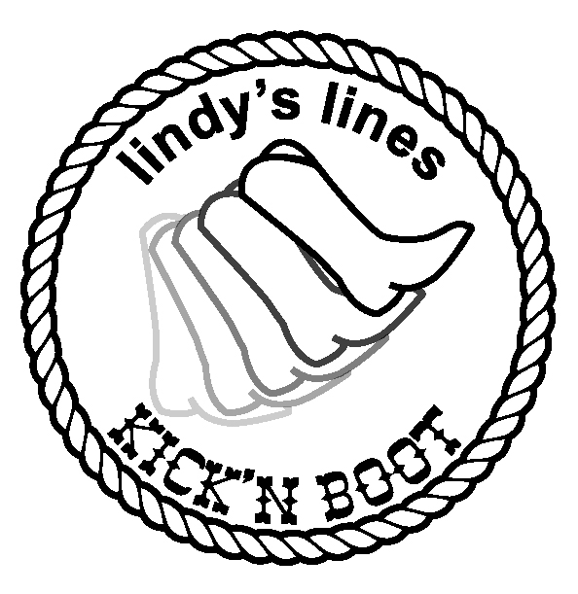
kicknboot@cfl.rr.com
http://groups.yahoo.com/group/lindyslines/

Karen Ritchie
magic.dancer@live.com

