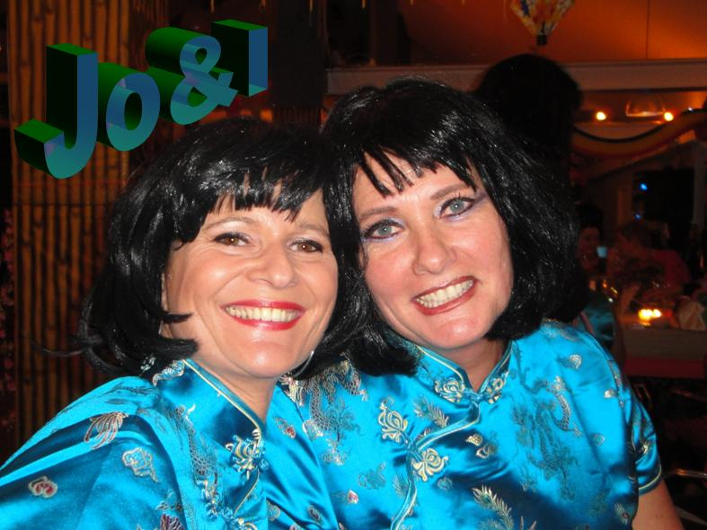
Promises Promises
Choreographer : Jo & I ( Dec 2009)
Music : Promises Promises – Lisa Lois ( CD Smoke)
64 Counts, Intermediate Linedance
Starts on the vocals after 16 counts in beat.

Sailorstep, 1/4 Sailorturn R, Walk Walk, Pivot 1/2 L with left sweep, Sailorstep.
1&2 Cross Step Left behind Right, Step Right to right side, Step Left to left side.
3&4 Cross Step Right behind Left, 1/4 Turn right step Left to left side, Step Right to right side. (3:00)
5-6 Walk forward Left, Walk forward Right.
&7&8 1/2 Pivot turn left with sweep Left from front to back, cross Step Left behind Right, Step Right to right side, Step Left to left side. (9:00)

Walk Walk, Kick Out Out, Sway R,L, Sway R &Turn L 1/4 with Hitch.
1-2 Walk forward Right, Walk forward Left.
3&4 Kick Right forward, Step Right to right side, Step Left to left side.
5-6 Push hips right, Push hips left.
7&8 Push hips right, Push hips left, Push hips right with ¼ turn Left-hitch Left knee. (6:00)

Step Turn 1/2 with Hitch, Cross rock Side, 1/4 Cross 1/4 Step, 1/2 Turn (Run L,R,L).
1-2 Step forward Left, Hitch Right knee turn 1/2 Left with weight on Left. (12:00)
3&4 Cross Rock Right over Left, Recover on Left, Step Right to right side.
5-6 Turn 1/4 right & cross Step Left over right, Turn 1/4 right Step Right forward. (6:00)
7&8 Make 1/2 Turn Right Run Left, Right, Left. (12:00)

1/4 Turn Step, Step Pivot 1/2 turn, Sway L, R, Sway L & Turn L 1/4 with Brush/Flick.
1-2 Turn 1/4 Right Step Right forward, Step Left forward. (3:00)
3&4 Step Right forward, Turn 1/2 Pivot Left, Step Right forward. (9:00)
5-6 Step Left to Left-Push hips Left, Push hips Right.
7&8 Push hips Left, Push hips Right, Turn 1/4 Left – Brush/Flick Right to the back. (6:00)

Walk Walk, Step Lock Step, Pivot 3/4 Turn R, Chassee 1/4 Turn L.
  - Walk Right Forward, Walk Left Forward.
3&4 Step Right Forward, Lock Left behind Right, Step Right Forward.
5-6 Step Left Forward, Turn 3/4 Right (weight ends on Right). (3:00)
7&8 Step Left to Left, Step Right next Left, Turn 1/4 Left Step Left forward. (12:00)

Sweep 1/4 Turn L. Touch, Forward Lockstep, Rock Recover, Lockstep Back.
1-2 Turn 1/4 Left-Right sweep from behind to front, Touch Right infront of Left. (9:00)
3&4 Step Right forward, Lock Left behind Right, Step Right forward,
5-6 Rock Left forward, Recover weight Right.
7&8 Step Left back, Lock Right in front of Left, Step Left back.

Side Touch, Side Touch, Side Together, Chassee 1/4 Turn R.
1-2 Step Right to Right side, Touch Left diagonaly to Right.
3-4 Step Left to Left side, Touch Right diagonaly to Left.
5-6 Step Right to Right side, Step Left next Right,
7&8 Step Right to Right side, Step Left next Right, Turn 1/4 right Step Right forward. (12:00)
***Tag/restart 3rd wall

Step 1/2 Pivot Turn, Walk Walk, Mambo Step forward, Mambo step back, Point.
1-2 Step Left forward, Turn 1/2 Right (Pivot) (6:00)
3-4 Walk Left forward, Walk Right forward.
5&6 Rock Left forward, Recover weight Right, Step Left slightly back
&7& Rock Right back, Recover weight Left, Step Right forward.
8 Point Left to Left side. (start the dance again with Left Sailorstep).

***Tag/restart In 3rd Wall:
Dance until count 56 “Step Right to Right side, Step Left next Right, Turn 1/4 right Step Right forward.”. (12:00)
Than dance the last 4 counts = (Tag) of the dance:
5&6 Rock Left forward, Recover weight Right, Step Left slightly back
&7& Rock Right back, Recover weight Left, Step Right forward.
8 Point Left to Left side. (start the dance again with Left Sailorstep).

