Natural Woman Waltz

Description: 48 count, 4 wall, Beginner Line Dance
Music: You Make Me Feel (Like A Natural Woman) by the Vocal Ballad Community
Begin On The 24th Count
Choreographed by Jackie Lincoln in Virginia Beach
okeefejl@charter.net
www.linedancingvirginia.vpweb.com/

FORWARD BASIC STEPS, BACK BASIC STEPS, BASIC ½ TURN LEFT, BACK BASIC STEPS
1-3 Step L foot forward, step R foot beside left, recover on L foot
4-6 Step R foot back, step L foot beside right, recover on R foot
7-9 Step L foot forward, step R foot back while turning ½ left, step L foot beside right (6:00)
10-12 Step R foot back, step L foot beside right, recover on R foot

FORWARD BASIC STEPS, BACK BASIC STEPS, BASIC ½ TURN LEFT, BACK BASIC STEPS
1-3 Step L foot forward, step R foot beside left, recover on L foot
4-6 Step R foot back, step L foot beside right, recover on R foot
7-9 Step L foot forward, step R foot back while turning ½ left, step L foot beside right (12:00)
10-12 Step R foot back, step L foot beside right, recover on R foot

DIAMOND WALTZ STEPS
1-3 Step L foot forward while turning ¼ left, step R foot next to left, recover on L foot (3:00)
4-6 Step R foot back while turning ¼ left, step L foot beside right, recover on R foot (6:00)
7-9 Step L foot forward while turning ¼ left, step R foot next to left, recover on L foot (9:00)
10-12 Step R foot back while turning ¼ left, step L foot beside right, recover on R foot (12:00)

TWINKLE STEPS, TWINKLE ¼ TURN,
1-3 Cross L foot over right, step R foot to right side, recover on left
4-6 Cross R foot over left, step L foot to left side, recover on right
7-9 Cross L foot over right, step R foot to right side, recover on left
10-12 Cross R foot over left, step L foot to left side while turning ¼ to right, step R to right side (3:00)

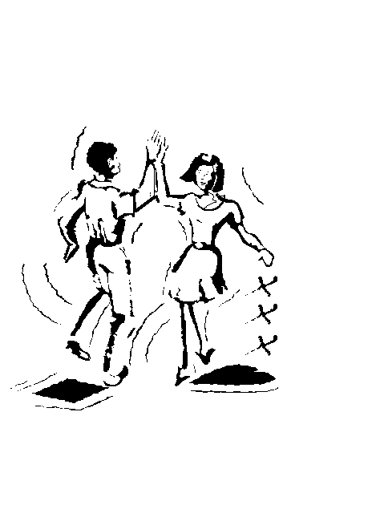
Begin again!

