MADAM BUTTERFLY
Choreographed by Karla & Paul Dornstedt
E-mail: kpdmagic15@hotmail.com
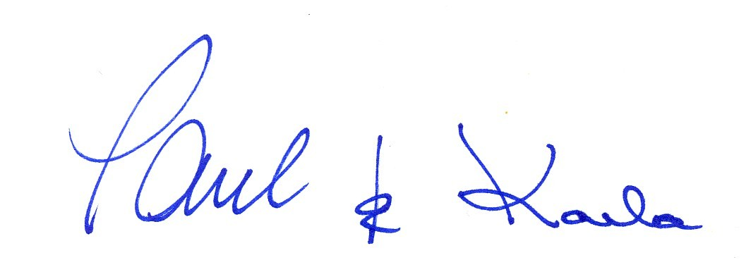

Description: 64 count, 2 wall, intermediate line dance
Music: She’s The Only One by Bread, Lead in 32 cts. BPM 136
CD Anthology of Bread
_________________________________________________________________________________

1 - 8 STEP, SWEEP, STEP, SWEEP, ROCK, RECOVER, 1/4 TURN LEFT, HOLD
1 - 2 Step left forward and slightly across right, sweep right forward
3 - 4 Step right forward and slightly across left, sweep left forward
5 - 6 Cross rock left over right, recover weight back on right
7 - 8 Turn ¼ left and step forward on left, hold (9:00)

9 -16 FORWARD, 1/2 LEFT, FORWARD, HOLD
1/2 RIGHT, 1/2 RIGHT, FORWARD, 1/4 RIGHT
1 - 2 Step forward on right, turn 1/2 left and step on left (3:00)
3 - 4 Step forward on right, hold
5 - 6 Turn 1/2 right and step back on left, turn 1/2 right and step forward on right (3:00)
7 – 8 Step forward on left, turn 1/4 right and step on right (6:00)

Alternate steps for 5 – 6
Small step forward on left, small step forward on right

17 - 24 CROSS, HOLD, ROCK, RECOVER
ROCK, RECOVER, 1/4 RIGHT, 3/4 RIGHT SPIN / TOUCH
1 - 4 Cross left over right, hold, rock right side right, recover weight on left
5 - 6 Rock right behind left, recover weight on left
7 - 8 Turn 1/4 right and step forward on right, spin 3/4 right on the ball of right and touch left next to right

Alternate steps for 7 – 8
Step right side right, touch left next to right

25 - 32 BACK, BACK, BACK, TOUCH
ROCK FORWARD, RECOVER, STEP FORWARD, SWEEP
1 - 4 Step back on left, step back on right, step back on left, touch right in front of left
5 - 8 Rock forward on right, recover weight back on left, step forward on right, sweep left forward and across right

33 - 40 CROSS, SIDE, BEHIND, SWEEP
BEHIND, SIDE, CROSS, HOLD
1 - 4 Cross left over right, step right side right, cross left behind right, sweep right forward to back and behind left
5 - 8 Cross right behind left, step left side left, cross right over left, hold

41 - 48 1/4 LEFT, FORWARD, 1/2 LEFT, 1/4 LEFT
BEHIND, 1/4 RIGHT, FORWARD, 1/4 RIGHT

1 - 2 Turn 1/4 left and step forward on left, step forward on right (3:00)

3 - 4 Turn 1/2 left and step on left, turn 1/4 left and step right side right (6:00)

5 - 6 Cross left behind right, turn 1/4 right and step forward on right (9:00)
7 - 8 Step forward on left, turn 1/4 right and step on right (12:00)

Page 1 of 2
MADAM BUTTERFLY continued Page 2 of 2

49 - 56 FORWARD, HOLD, ROCK FORWARD, RECOVER
1/2 RIGHT, HOLD, CROSS, BACK

1 - 2 Step forward on left, hold

3 - 4 Rock forward on right, recover weight back on left
5 - 6 Turn 1/2 right and step forward on right, hold (6:00)
7 - 8 Cross left over right, step back on right

57 - 64 SIDE, HOLD, ROCK BACK, RECOVER
SIDE, HOLD, ROCK BACK, RECOVER
1 - 2 Step left side left, hold
3 - 4 Rock right behind left, recover weight forward on left
5 - 6 Step right side right, hold
7 - 8 Rock left behind right, recover weight forward on right

REPEAT

RESTART:
The fourth rotation starts on the back wall,
complete 56 counts and restart the dance facing the front wall.

ENDING (optional):
The last rotation starts on the back wall.
Complete 40 counts. (You will be facing the front wall) Take a long step to left on left
33 - 40 CROSS, SIDE, BEHIND, SWEEP
BEHIND, SIDE, CROSS, HOLD
1 - 4 Cross left over right, step right side right, cross left behind right, sweep right forward to back and behind left
5 - 8 Cross right behind left, step left side left, cross right over left, hold
41 Take a long step to left on left (12:00)

Page 2 of 2

