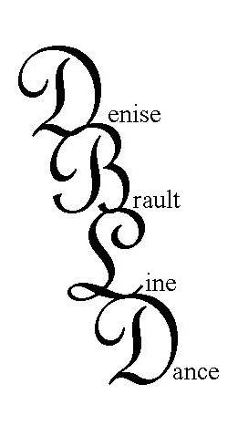
MASTERPIECE 2/10
Choreographed by: Denise Brault www.DeniseBrault.com
Denise.Brault@yahoo.com
Description: 48 count, 4 wall, ultra-beginner funky, 32 count intro
Music: What’s Your Name by Nathan CD: Masterpiece, available at www.cduniverse.com

1 – 8 STEP, TOUCH, BUMP AND BUMP, STEP, TOUCH, BUMP AND BUMP
1 - 2 Step right toward right diagonal, touch left toe beside right
3 & 4 Bump knees forward, back, forward (or shake hips, be funky)
5 – 6 Step left toward left diagonal, touch right toe beside left
7 & 8 Bump knees forward, back, forward (or shake hips, be funky)

9 – 16 *WALK RIGHT, LEFT, RIGHT, LEFT, RIGHT, LEFT, RIGHT, LEFT
1 – 8 Walk in a large circle to the right returning to 12:00 (with attitude)

17 – 24 STEP, TOUCH, BUMP AND BUMP, STEP, TOUCH, BUMP AND BUMP
1 - 2 Step right toward right diagonal, touch left toe beside right
3 & 4 Bump knees forward, back, forward (or shake hips, be funky)
5 – 6 Step left toward left diagonal, touch right toe beside left
7 & 8 Bump knees forward, back, forward (or shake hips, be funky)

25 – 32 *WALK RIGHT, LEFT, RIGHT, LEFT, RIGHT, LEFT, RIGHT, LEFT
1 – 8 Walk in a large circle to the right returning to 12:00 (with attitude)

33 – 40 STEP TOUCH, STEP TOUCH, STEP TOUCH, STEP TOUCH
1 - 2 Step right to right, touch left toe next to right
3 – 4 Step left to left, touch right toe next to left
5 - 6 Step right to right, touch left toe next to right
7 - 8 Step left to left, touch right toe next to left

41 – 48 BACK, BACK, BACK, TOUCH, STEP, LOCK, STEP, ¼ BRUSH
1 – 4 Walk back right, left, right, touch left toe next to right.
5 – 8 Step left forward, lock right behind left, step left forward, brush right making ¼ turn to left. (9:00)

Begin again!

*BOX VARIATION replacing circle walks for more experienced dancers:
1 – 2 Big step right to right, touch left toe next to right
3 – 4 ¼ turn left big step to left, touch right toe next to left (3:00)
5 – 6 ¼ turn right big step to right, touch left toe next to right (6:00)
7 – 8 ¼ turn left big step to left, (9:00) ¼ turn left touch right toe next to right (12:00)

Add your own funky variations! Have fun!

