The LaLa dance

Choreographers : Wil Bos and Roy Verdonk
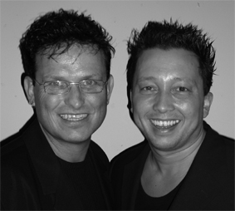
Level : Easy Intermediate
Dance : 32 counts, 4 wall
Music : Bob Sinclar ft. Sugarhill gang – LaLa song (radio edit)
CD : Born in ’69 - Amazon
Intro : 32 counts

Vine to the right, Side, Close, Side Shuffle ¼ turn
1-2 Step right to right side, Cross left behind right
3-4 Step right to right side, Touch left next to right
5-6 Step left to left side, Close right next to left
7&8 Step left to left side, Close right next to left, ¼ Turn left step left forward

Step, ¼ Turn, Cross Shuffle, Step, Drag, Close & Cross
1-2 Step right forward, ¼ Turn left
3&4 Cross right over left, Step left to left, side, Cross right over left
5-6-7 Step left to left side, Drag right towards left in 2 counts
&8 Close right next to left, Cross left over right

Step, Close, Shuffle forward, Step, Touch, Step, Touch
1-2 Step right to right side, Close left next to right
3&4 Step right forward, Step left next to right, Step right forward
5-6 Step left to left side, Touch right toe to right diagonal
7-8 Step right to right diagonal, Touch left toe to left diagonal

Rolling vine, ¼ Turn Step Out, Out, Step Back, Close
1-2 ¼ Turn left step left forward, ½ Turn left step back on right
3-4 ¼ Turn left step left to left side, Touch right next to left
5-6 ¼ Turn right step right forward (right hand up), Step left to left side (left hand up)
7-8 Step right back (right hand pointing down), Step left back next to right (left hand pointing down)

Start again keep smiling and place all the fun stuff you can make up in the dance.

