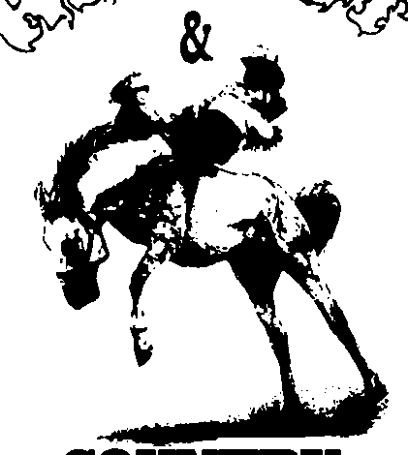
COUNTRY
LINEDANCERS
Samantha Kenny 0416163670
Email: sammysparrow73@hotmail.com

Lover Lover

Song: Lover Lover
Artist: Jerrod Niemann
Choreographers: Greg & Samantha Kenny April 2010
Description: 64 counts, 2 walls, Intermediate Line Dance, 1 tag, start on Vocals,

Rock fwd L, back on R behind ¼ R, Step on L, Pivot Half & Pivot ¼
1, 2,3&4 Rock/step L fwd, rock/replace weight back on R , sweep left foot behind right (weight to L),
Turn 90◦R step R Fwd, Step L fwd.
5,6,&7,8 Step R fwd, pivot turn 180° Left (weight to L),Step R beside L (weight on L),
Step L fwd, pivot turn 90° R (weight to R).
Rock fwd L, back on R,Diagonal Lock step back,Diagonal Lock step back, Rock Back L, Fwd on R
1,2,3&4 Rock/step L fwd. rock/replace weight back on R, Step left back at 45°Left,
cross right over left, step left back.
5&6,7,8 Step Right back at 45° Right, cross Left over Right, step Right back,
Rock/step L Back,Rock/replace weight Fwd on R.
Walk, Walk, point L to side, cross Left kick ball change, L sailor step,R sailor ¼ step
1&2,3&4 Step left forward, step right forward, touch left to side, cross kick L over R,
step L to L side , step R to R side (kick ball-change),
5&6,7&8 step L behind R, step R to side, Replace L to side, Step right behind L,
turn 90° right and step left fwd, step right forward.
Step Pivot ½ R, L shuffle fwd, Rock Fwd, Replace, Heel Jack & Step
1, 2,3&4 Step L fwd, pivot turn 180° right (weight to R),shuffle fwd (L.R.L)
5,6&7&8 Rock/step R fwd , replace weight back on L,( #) step R back together with L,
touch L heel fwd,Step L back together with R, step R fwd.
Hip & Hip & Hip & Hip, Rock fwd R, back on L, ¾ R Triple Step.
1&2&3&4 Step Fwd L 45° bumping hips fwd, back, fwd, back, fwd, back, fwd (Optional 4 clicks with hips)
5,6,7&8 Rock/step R fwd, rock/replace weight back on L, Turning 270° R Triple step R,L,R
L Dorothy,&, R Dorothy, Side behind & Cross & Heel.
1,2&3,4& Step left foot 45°,Lock right behind left & step forward on left, Step right foot 45°,
Lock left behind right & Step forward on right.
5,6&7&8 Step L foot to L side, Step R behind L, Step L to L side, Step R in front of L,
Step L to L side, R Heel 45° R.
& Cross, hold, &, cross, hold, Side Rock behind side fwd
&1,2&3, 4 Step R beside left, cross/step L over R, hold (Optional R finger click), step R slightly Right, Cross/step L over R Hold (Optional R finger click)
5,6, 7&8 Rock right to right side , recover to left, Cross right behind left,
Step left to side, Step right fwd.

Rock fwd L, back on R, shuffle back, Rock back R, fwd on L, shuffle fwd.
1,2,3&4 Rock/step L fwd, rock/replace weight back on R, Left shuffle back (L.R.L)
5,6,7&8 Rock/step R back, rock/replace weight fwd on L, Right shuffle fwd (R.L.R)
64 Start dance again
# Note- a restart occurs during wall 2 at count 32 dance up to count 30 then do the following
7&8 step R back, make 90° turn L step L to side, step R fwd (weight on R) (restart front wall)

