Little White Church Bell

Description: 32 count, 4 wall, Beginner Line Dance
Music: Little White Church by Little Big Town
Begin On The 32nd Count
Choreographed by Jackie Lincoln in Virginia Beach
okeefejl@charter.net
www.linedancingvirginia.vpweb.com/

TOE TAPS, BEHIND SIDE CROSS, REPEAT
1-2 Touch R toe to right side, repeat
3&4 Cross R foot behind left, step L foot to left, cross R foot over left
5-6 Touch L toe to left side, repeat
7&8 Cross L foot behind right, step R foot to right, cross L foot over right

FORWARD STOMPS, SCUFF, HITCH STOMP, REPEAT
1-2 Stomp R foot forward, stomp L foot forward
3&4 Scuff R foot forward, raise R knee straight up, stomp R foot forward
5-6 Stomp L foot forward, stomp R foot forward
7&8 Scuff L foot forward, raise L knee straight up, stomp L foot forward

SAILOR STEPS, REPEAT
1&2 Step R foot behind left, step L foot next to right, step R foot to right side
3&4 Step L foot behind right, step R foot next to left, step L foot to left side
5&6 Step R foot behind left, step L foot next to right, step R foot to right side
7&8 Step L foot behind right, step R foot next to left, step L foot to left side

JAZZ BOX WITH 1/8 TURN RIGHT, REPEAT
1-2 Cross R foot over left, step L foot back
3-4 Make 1/8 turn right stepping R foot forward, step L foot forward (1:30)
5-6 Cross R foot over left, step L foot back
7-8 Make 1/8 turn right stepping R foot forward, step L foot forward (3:00)

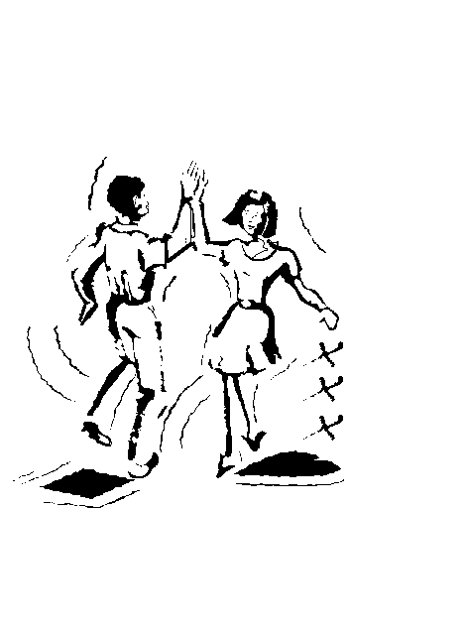
BEGIN AGAIN

