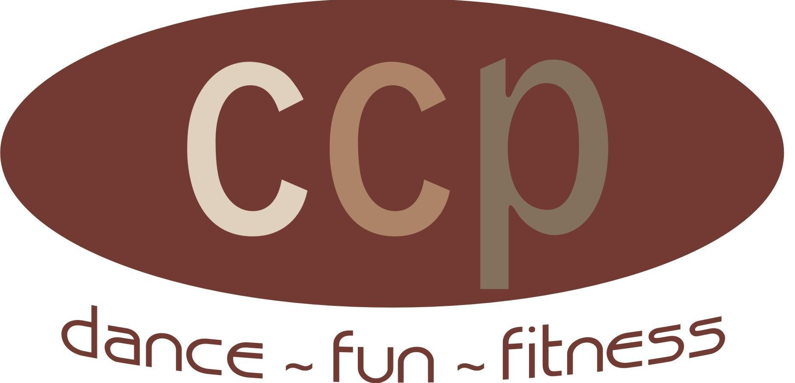

KISS THIS

Choreography by: Kathy Hinchman/C.C. Plus – Dance ~ Fun ~ Fitness, Inc. Jan/2011
KathyHinchman@gmail.com
32 count/Beginner level/no tags or restarts
Music: Practice Piece: Blue Bayou – Linda Ronstadt available on iTunes
Signature Piece: Kissed It – Macy Gray available on iTunes

STEP, TOGETHER, ROCK, RECOVER, TRIPLE STEP
1-4 Step R, step L together, step R, step L together, weight on L
5-6Rock forward on R, recover on L
7&8Triple step R, L, R
STEP, TOGETHER, ROCK, RECOVER, TRIPLE STEP
1-4Step L to left, step R together, step L to left, step R together, weight on R
5-6Rock forward on L, recover on R
7&8Triple step L, R, L
WALK FORWARD, KICK, WALK BACK, COASTER STEP
1-4Walk forward R, L, R, kick L
5-6Walk back L, R
7&8Coaster Step L, R, L
TWO SHUFFLES FORWARD, PIVOT 1/2, STOMP R, L
1&2Shuffle forward R, L, R
3&4Shuffle forward L, R, L
5-6Step forward on R, pivot ½ over left shoulder
7-8Stomp R, Stomp L
**You can also substitute a double left bump, booty shake, or blow a kiss for last two counts. Make it your own style!

Start again!

Variations:
*You can make this a contra dance, two lines facing each other.
*You can make this a circle dance if intermediate dance to this song is on the center floor. Dancers facing line of dance to start and then with the ½ turn the dance begins again facing opposite line of dance.

www.ccplusdance.com

