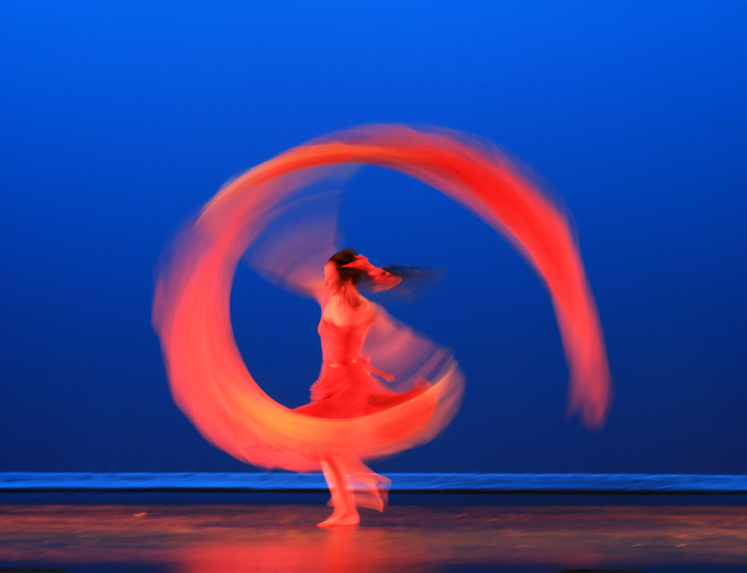 Jingle Bell Rock
December 4, 2010
Count: 32 | Wall: 1 | Beginner
Choreographer: | Cross Border Dancing Diva |  |  | Music: | Jingle Bell Rock by Brenda Lee, [CD: Christmas with the Cranks]  Rocking Little Christmas by Brooks and Dunn  Santa’s Coming Over to Your House: Brooks and Dunn
Jingle Bell Rock Brenda Lee
Rocking Around the Christmas Tree/B and Dunn: Rocking Little Christmas
Santa’s Coming To Your House, Brooks and Dunn
Intro: 16 counts
[1-8] LINDY R L, (R CHASSE, BACK ROCK, RECOVER, L CHASSE, BACK ROCK, RECOVER)
1&2Step right to right, step left beside right, step right to right
3-4Rock left back, recover onto right
5&6Step left to left, step right beside left, step left to left
7-8Rock right back, recover onto left
[9-16] SHUFFLE R L, ROCK FWD, R, ½ SHUFFLE TURN R,
1&2Shuffle Fwd, R,
3&4Shuffle Fwd L
5-6Rock Right Fwd, Recover L,
7&8 ½ Shuffle Turn R, (to 6:00)
[17-24] STEP L, TOUCH R, STEP R, TOUCH L, VINE L WITH ½ TURN HITCH
1-2 -3-4 Step L, touch R to L instep, step R, touch L to R instep
5-8 Vine L (Step L, R step behind L, Step L and turn ½ in opposite direction on ball of L Foot, Hitch R,)
[25-32] VINE RIGHT, CLAP, VINE LEFT, BRUSH R
1-4 Step on R, L behind right, step right, touch L And Clap
5-8 Step on L, R behind L, step left, brush R into Lindy and start again.

(NOTE: When dancing to Brooks and Dunn, add walk fwd R,L,R,L AFTER THE FINAL VINE LEFT for the 4 count bridge they add to the music. )
Contact the Choreographer: Elena Hill at 310-293-9958 or email: elenahill56@yahoo.com

