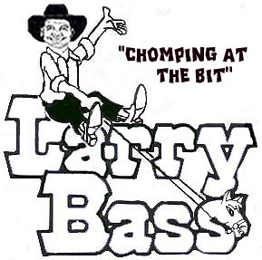

It’s My Way
Choreographed 2-8-11 by Larry & Carol Bass

Inquiries: (Larry Bass PH/FAX 904-737-2144); E-mail: lbass6622@comcast.net
6405 Starling Ave. Jacksonville, Fl. 32216

Description: 4 wall, 32 count beginner line dance
Music: “I Want It That Way” by The Backstreet Boys

SKATE, SKATE, DIAGONAL TRIPLE STEP FORWARD; SKATE, SKATE, DIAGONAL TRIPLE STEP FORWARD
1-2 Skate right forward, skate left forward
3&4 Triple step right diagonal forward Right, Left, Right
5-6 Skate left, skate right
7&8 Triple step left diagonal forward Left, Right, Left

CROSSOVER, BACK, DIAGONAL TRIPLE STEP BACK; CROSSOVER, BACK, DIAGONAL TRIPLE STEP BACK
1-2 Step Right across Left; Step Left back
3&4 Triple step right diagonal back Right, Left, Right
5-6 Step Left across Right; Step Right back
7&8 Triple step left diagonal back Left, Right, Left

MODIFIED WEAVE, SAILOR STEP; MODIFIED WEAVE, ¼ TURN COASTER STEP
1-2 Step Right across Left; Step Left to left side
3&4 Step Right behind Left, Step Left to left side, Step Right to right side
5-6 Step Left across Right; Step Right to right side
7&8 Turn ¼ turn left & step Left back, Step Right beside Left, Step Left forward

CROSSOVER ROCK STEP, TRIPLE STEP; CROSSOVER ROCK STEP, TRIPLE STEP
1-2 Step Right across Left; Rock back onto Left
3-4 Triple step Right, Left, Right
5-6 Step Left across Right; Rock back onto Right
7&8 Triple step Left, Right, Left

START OVER

