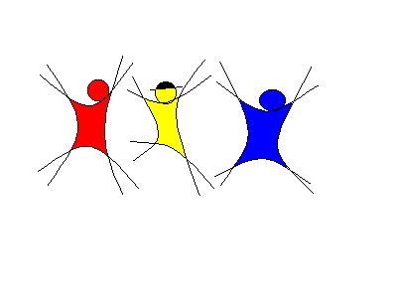

SJlinedancer

( www.sjlinedancer.blogspot.com )
ISO KAMPONG TOH
Choreographed by Agnes Sipula Vun ( August 2010 )
64 counts, 4 walls, beginner line dance
Song used: Iso Kampong Toh by Francis Landong
Start the dance on vocal after 80 counts of hard beats.
( Note: Iso Kampong Toh means We Came From The Same Village )

RIGHT LINDY, LEFT SIDE CHA CHA, BEHIND, SIDE
1&2 Cha cha to right side on RLR
3-4 Cross left behind right, recover onto right
5&6 Cha cha to left side on LRL
7-8 Cross right behind left, step left to left side

CROSS, HOLD, SIDE, HOLD, CROSS, HOLD, POINT, HOLD
1-2 Cross right over left, hold
3-4 Step left to left side, hold
5-6 Cross right over left, hold
7-8 Point left to left side, hold

CROSS, HOLD, SIDE, HOLD, CROSS, HOLD, POINT, HOLD
1-2 Cross left over right, hold
3-4 Step right to right side, hold
5-6 Cross left over right, hold
7-8 Point right to right side, hold

RIGHT & LEFT FORWARD TOE STRUTS, SIDE-ROCK-CROSS, HOLD
1-2 Touch right toes forward, step right heel down
3-4 Touch left toes forward, step left heel down
5-6 Rock right to right side, recover onto left
7-8 Cross right over left, hold

LEFT & RIGHT FORWARD TOE STRUTS, SIDE-ROCK-CROSS, HOLD
1-2 Touch left toes forward, step left heel down
3-4 Touch right toes forward, step right heel down
5-6 Rock left to left side, recover onto right
7-8 Cross right over left, hold

RIGHT & LEFT TOE-HEEL-CROSS, HOLD
1-2 Touch right toes beside left, touch right heel beside left
3-4 Cross right over left, hold
5-6 Touch left toes beside right, touch left heel beside right
7-8 Cross left over right, hold

1/4 TURN LEFT BUMP HIPS RLRL, 1/2 TURN RIGHT BUMP HIPS RLRL
1-4 Turning 1/4 left bump hips RLRL
5-8 Turning 1/2 right bump hips RLRL

SIDE-TOUCH X 4
1-2 Step right to right side, touch left together
3-4 Step left to left side, touch right together
5-6 Step right to right side, touch left together
7-8 Step left to left side, touch right together

RESTART during wall 5 after 48 counts.

Youtube video: http://www.youtube.com/watch?v=IUNbqQBeY_Y

