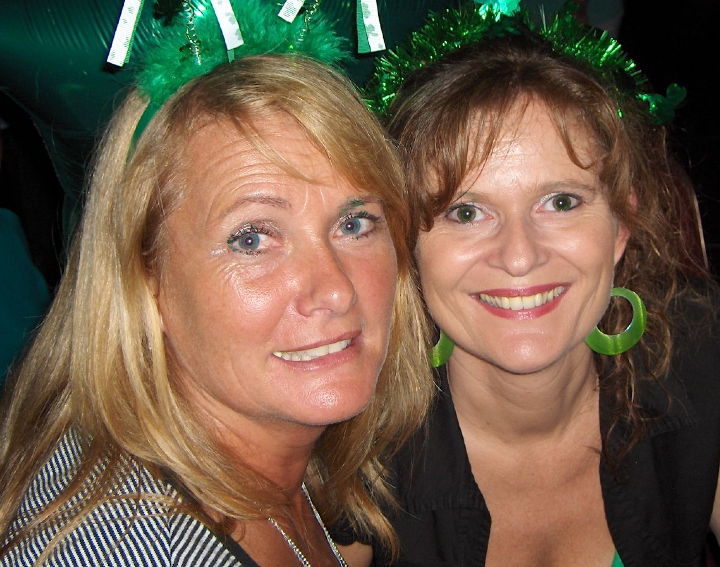
I’m Here.

Choreographer : Jo & I
Music : Estoy Aqui - Shakira
32 Counts 2 Wall Intermediate Linedance with one restart
Start after 64 Counts Intro

SAMBA ¼ TURN HITCH, COASTER STEP, CROSS, ROCK STEP, MAMBO ¼ TURN RIGHT.
1&2& Lf cross over rf, ¼ turn left & step rf back, lf step back, hitch right knee
3&4 Rf step back, lf step back, rf step forward
5&6 Lf cross over rf, rf rock side, weight on lf
7&8 Rf cross rock over lf, lf weight back on lf, ¼ turn right step rf to the side ***

SAMBA ¼ TURN HITCH, COASTERSTEP, STEP ½ TURN LEFT WITH SWEEP, KICK BALL TOUCH.
1&2& Lf cross over rf, ¼ turn left & step rf back, lf step back, hitch right knee
3&4 Rf step back, lf step back, rf step forward
5,6 Lf step forward, ½ turn left & sweep right foot to front
7&8 Rf kick forward, rf step in place, lf touch forward

STEP TOUCH, FLICK WITH ½ TURN RIGHT, STEP, ½ TURN RIGHT, 4X STEP TOUCH BACK.
& 1,2,&,3 Weight on lf, rf touch forward, rf flick to right side (right knee stay close to
left), hitch right knee, ½ turn right, step rf forward
4 ½ turn right step lf back
&5&6 Rf step back, touch lf forward, ff step back, touch rf forward,
&7&8 Rf step back, touch lf forward, ff step back, touch rf forward,

& CROSS BACK STEP, STEP 1/2 TURN STEP, JAZZ BOX 1/4 LEFT, WALK TOUCH
&1&2 Rf next Lf, Lf cross in front Rf, Rf step back, Lf next Rf.
3&4 Rf step forward, Turn 1/2 to the right LF step next Rf, Rf step forward.
5&6 Lf cross in front Rf, Turn 1/4 left Step Back on Rf, Lf step to the left side.
7 8 RF step forward, LF touch
Option 7&8 Right triple turn

***Restart: 4rd Wall after the first 8 counts.
(dance 3 full sections, in wall 4 dance only the first 8 counts and start again)

Have fun!

