Hook Shot | 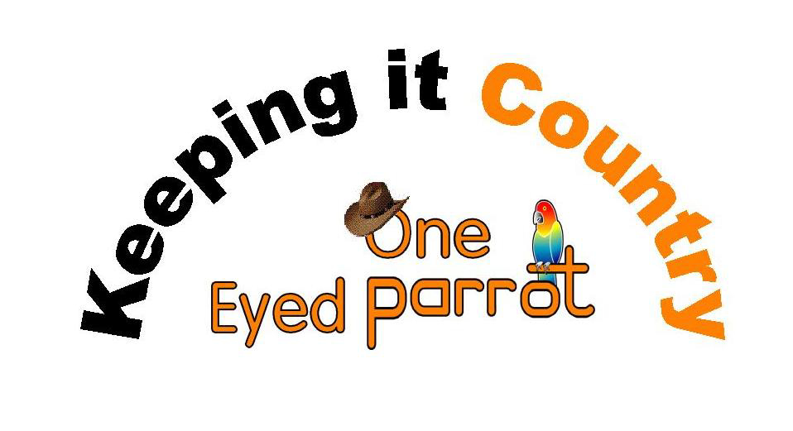
Choreographer: Jason Reome
Description: 4 Wall, 32 count, Beginner/Intermediate line dance
Music: “I Like it I Love It” by Tim McGraw

STEP, PIVOT ½ LEFT, ½ TURNING SHUFFLE LEFT, COASTER BACK, SCUFF FWD, BRUSH ACROSS
1-2 Step right forward, pivot ½ left
3&4 Shuffle right, left , right while turning ½ left (12:00)
5&6 Step left back, step right next to left, step left forward (coaster step)
7-8 Scuff right heel forward, brush ball of right across left foot

TAP RIGHT TOE TWICE, SCUFF, SIDE, BEHIND, SIDE, TOUCH HEEL, TOGETHER, CROSS, SIDE
9-10 Tap right toe across left twice
11-12 Scuff right heel forward, step right foot to right side
5&6 Step left behind right, step right to right side, touch left heel toward left diagonal
&7,8 Step left next to right, cross right over left, step left to side (12:00)

¼ RIGHT SAILOR STEP, ROCK STEP, ¼ LEFT SAILOR STEP, ROCK STEP
17&18 Cross right behind left, step left in place turning ¼ right, step right forward (03:00)
19-20 Rock left forward, recover weight on right
21&22 Cross left behind right, step right in place turning ¼ left, step left forward (12:00)
  - Rock right forward, recover weight on left

COASTER STEP, PIVOT ½ RIGHT, PIVOT ¼ RIGHT, HEEL, STEP
25&26 Step right back, step left next to right, step right forward (coaster step)
27-28 Step forward left, pivot ½ turn right (06:00)
29-30 Step forward left, pivot ¼ turn right (09:00)
31-32 Touch left heel forward, step forward on left (weighted)

START OVER

OneEyedParrot.Org

