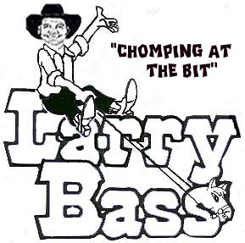

Gonna Get Up
Choreographed Dec. 24, 2010 by Larry Bass

Inquiries: (Larry Bass PH: 904-737-2144); E-mail: lbass6622@comcast.net
6405 Starling Ave. Jacksonville, Fl. 32216

Description: 32 count, 4 wall, intermediate line dance
Music: “Gonna Get Up” by Mr. President [Night Club CD] (Start After 32 counts)

HEEL & HEEL & STEP FORWARD, SLIDE TOUCH; HIP & HIP &, KICK-BALL-CROSS
1& Touch Right heel forward, Step Right beside Left
2& Touch Left heel forward, Step Left beside Right
3-4 Step Right forward; Slide & touch Left beside Right
5&6& Bump hips Left, Center, Left, Center
7&8 Kick Left forward, Step ball of Left beside Right, Step Right across Left (12:00)

STEP SIDE, SAILOR STEP, BEHIND, SIDE, CROSS; BUMP & BUMP & BUMP
1-2&3 Step Left to left side; Step Right behind Left, Step Left to left side, Step Right to right side
4&5 Step Left behind Right, Step Right to right side, Step Left across Right
6-8 Step Right to right side & bump hips Right, Center, Right, Center, Right (12:00)

CROSSOVER MAMBO STEP, CROSSOVER MAMBO STEP ¼ TURN; ½ TURN TRIPLE STEP,
COASTER STEP
1&2 Step Left across Right, Rock back onto Right, Step Left beside Right
3&4 Step Right across Left, Rock back onto Left, Turn ¼ turn right & step Right forward (3:00)
5&6 Turn ½ turn right & triple step Left, Right, Left (9:00)
7&8 Step Right back, Step Left beside Right, Step Right forward

SKATE, SKATE, ROCK STEP ½ TURN; STEP ½ PIVOT, ½ TURN, COASTER STEP
1 Push left forward & diagonally to left while stepping on left
2 Push right forward & diagonally to right while stepping on right
3&4 Step Left forward, Rock back onto Right turning ½ turn left, Step Left forward (3:00)
5&6 Step Right forward, Pivot ½ turn left onto Left, Turn ½ turn left & step Right back (9:00)
7&8 Step Left back, Step Right beside Left, Step Left forward

START OVER

