giddy on out
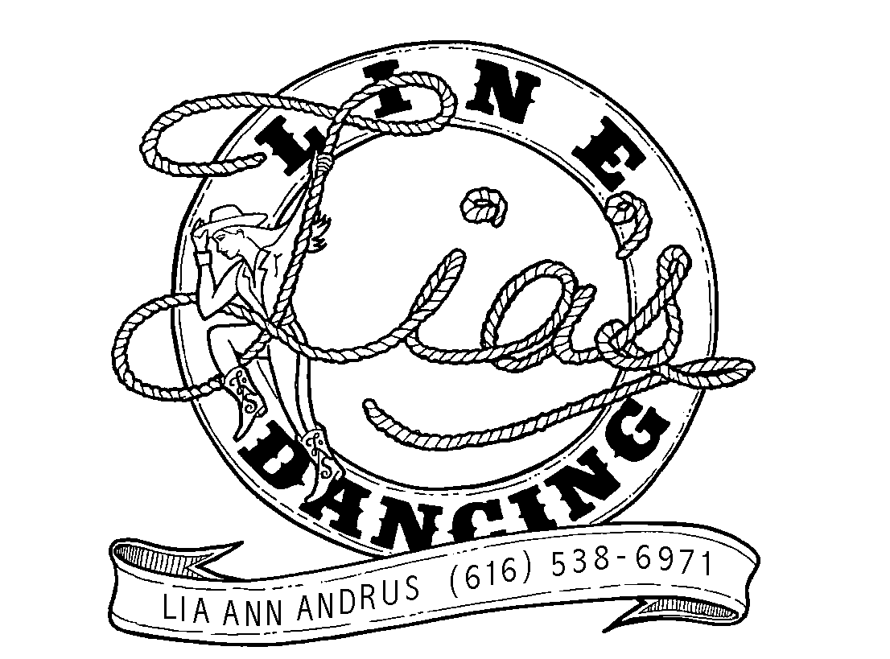

intermediate phrased Line Dance - 4 Wall - 32 counts
CHOREOGRAPHED BY Lia andrus and al dykstra
MUSIC: giddy on up (by: Laura Bell Bundy)
youtube video: http://www.youtube.com/watch?v=X1gpAzTZja4

kick-ball change-kick-hook-kick-flick
1&2 kick right forward-step right next to left ON BALL OF FOOT-STEP LEFT NEXT TO RIGHT
&3 kick right forward-hook right in front of left
&4 kick right forward-flick right out to right side

scuff-hitch-step-scuff-hitch-step-squat-stand
&5& scuff right across and in front of left-hitch right knee up and around to right side-step down on right to right side
6&7 scuff left across and in front of right-hitch left knee up and around to left side-step down on left to left side
&8 (now standing with feet at least shoulder width apart) squat bending both knees-then straighten knees

wizard step right and left-rock w/ push-step-step back-bump up-down
1-2& step right to right corner-step behind right on ball of left-step right to right
3-4& step left to left corner-step behind left on ball of right-step left to left
5-6 rock right to right as your left comes up and right hand crosses in front of chest pushing hand left-step down on left, returning hand down
7&8 step back on right BENDING KNEES-bump left hip up-bump left hip down

CROSSING l heel jack-step-together-swivel heels out RIGHT-in-repeat
1&2 cross left over right-step right to right-touch left heel to left corner
&3 step left next to right-touch right next to left to center
&4 swivel both heels out to right-return heels back left
aRMS: ON &4 WITH FISTS AT CHEST AND ELBOWS OUT, MOVE FISTS TO RIGHT SHOULDER THEN RETURN THEM BACK CENTER
5-8 REPEAT ABOVE 1-4

gallop left-gallop right-rock-step-1/4 step l-touch r
1&2 turn ¼ left & step left forward-step right behind left-step left forward
Arms: closed fists, AT CHEST, ELBOWS OUT, push from chest forward on count 1, back to chest on count & then forward on count 2
3&4 turn ½ right & step right forward-step left behind right-step right forward
Arms: closed fists, ELBOWS OUT, AT CHEST, push from chest forward on count 3, back to chest on count & then forward on count 4
5-6 turn ¼ left & rock forward on left-rock back on right
7-8 turn ¼ left & step left to left-touch right next to left
lasso right arm around one time on 5-6

Tags: you will have 2 easy tags on walls 4 & 7, right after she says “giddy on up, giddy on out” 5,6,7,8. (very easy to hear in the music)
1-4 bump hips right-left-right-left

restart: There is also one easy restart. On wall 4 ONLY, right after you do your tag, do the first 8 counts of the dance 2 times and then continue the dance from that point as normal WITH THE wizard stepS.

