
FROM THE BOTTOM
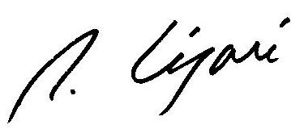
OF MY HEART

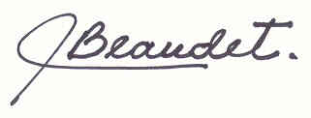

Dance : 4 walls (32 counts + 1 restart), beginner/intermediate
Choreographers : Pierre Legare (November 2008)
with the collaboration of Johane Beaudet – APDEL Certified Teacher
Website : www.lesfansducountry.com – E-mail : beaudetlegare@sympatico.ca
Music : I Just Called To Say I Love You (Jason Allen) – 132 BPM – start after 16 counts

1 – 8 STOMP, HOLD, STOMP, HOLD, WALK, WALK, SHUFFLE FORWARD
1, 2 Stomp down R forward + hold
3, 4 Stomp down L forward + hold
5, 6 Walk forward RL
7 & 8 Shuffle forward RLR

9 – 16 STEP, PIVOT 1/4 TURN RIGHT, WEAVE 1/4 TURN RIGHT, SHUFFLE FORWARD
1, 2 Step L forward + pivot ¼ turn right (3:00)
3, 4 Cross L in front of R + step R to the right side
5, 6 Cross L behind R + make ¼ turn right & step R forward (6:00)
7 & 8 Shuffle forward LRL

Restart A restart is needed during Wall 7 (facing 6 o’clock). Dance up to Count 16 then start the dance again from the beginning (facing 12 o’clock).

17 – 24 STEP, PIVOT 1/4 TURN LEFT, WEAVE 1/4 TURN LEFT, SHUFFLE FORWARD
1, 2 Step R forward + pivot ¼ turn left (3:00)
3, 4 Cross R in front of L + step L to the left side
5, 6 Cross R behind L + make ¼ turn left & step L forward (12:00)
7 & 8 Shuffle forward RLR

25 – 32 ROCK STEP, STEP 1/4 TURN LEFT, SCUFF, STEP, PIVOT 1/2 TURN LEFT, KICK-BALL-CHANGE
1, 2 Rock L forward + recover
3, 4 Make ¼ turn left & step L slightly forward (9:00) + scuff R
5, 6 Step R forward + pivot ½ turn left (3:h00)
7 & 8 Kick R forward + ball R slightly back + step L in place

Have fun !
I JUST CALLED TO SAY I LOVE YOU
Singer : Jason Allen
No New Year's Day to celebrate
No chocolate covered candy hearts to give away
No first of spring
No song to sing
In fact here's just another ordinary day
No April rain
No flowers bloom
No wedding Saturday within the month of June
But what it is, is something true
Made up of these three words that I must say to you
I just called to say I love you
I just called to say how much I care
I just called to say I love you
And I mean it from the bottom of my heart
No summer's high
No warm July
No harvest moon to light one tender August night
No autumn breeze
No falling leaves
Not even time for birds to fly to southern skies
No Libra sun
No Halloween
No giving thanks to all the Christmas joy you bring
But what it is, though old so new
To fill your heart like no three words could ever do
I just called to say I love you
I just called to say how much I care, I do
I just called to say I love you
And I mean it from the bottom of my heart
I just called to say I love you
I just called to say how much I care, I do
I just called to say I love you
And I mean it from the bottom of my heart, of my heart, of my heart
I just called to say I love you
I just called to say how much I care, I do
I just called to say I love you
And I mean it from the bottom of my heart, of my heart, baby of my heart

