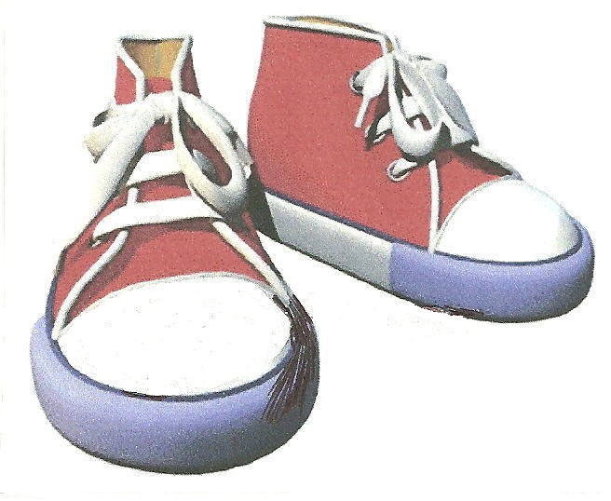 FANCY FOOTWORK

Choreographed by: Harlan Curtis - January 10, 2011
E-Mail: hccurtis@roadrunner.com
Diamond Bar, California, USA
Description: 32 count, 4 wall, Beginner/Intermediate Line Dance
Music: “Fancy Footwork" by Chromeo, 3:18 min version
CD Album: Fancy Footwork, Deluxe Edition, May 8, 2007
CD Label: Last Gang Records Inc.
Genre : Pop, 129 BPM
Music is available on the artist’s website www.idacorr.net,
Amazon.com, and iTunes
Start dancing on lyrics (48 counts in)
Counts Step Descriptions
SIDE ROCK, RECOVER, BEHIND & CROSS, SIDE ROCK, RECOVER, CROSS & CROSS
1-2 Rock left to side, recover on right
3&4 Step left behind right, step right to side, cross left over right
5-6 Rock right to side, recover on left
7&8 Cross right over left, step left to side, cross right over left

1/4 TURN LEFT, STEP RIGHT, 1/2 TURN LEFT TRIPLE STEP, KICK BALL WALK, KICK BALL WALK
1-2 Step 1/4 turn left, step right next to left 9:00
3&4 Triple step 1/2 turn left by stepping left, right, left 3:00
5&6 Kick right forward, step right forward, step onto left slightly ahead of right
7&8 Kick right forward, step right forward, step onto left slightly ahead of right

FORWARD ROCK, RECOVER, 1/2 TURN RIGHT TRIPLE STEP, STEP TOUCH,
STEP HOOK
1-2 Forward rock on right, recover on left
3&4 Triple step 1/2 turn right by stepping right, left, right 9:00
5-6 Step forward on left, tap right toe behind left
7-8 Step back on right, hook left foot in front of right

LOCK STEP FORWARD, PIVOT 1/2 TURN LEFT, JAZZ BOX, STEP RIGHT,
HOLD & CLAP
1&2 Step forward left, lock right behind left, step forward on left
3-4 Step right forward, pivot 1/2 turn left 3:00
5-6 Cross right over left, step left slightly back
7-8 Step right to side, hold and clap
Ending of dance -

On last wall (wall 11), steps 5-6 Cross right over left, step left slightly back
steps 7-8 Step 1/4 turn right stepping right facing the front wall,
step left next to right and pose with a big smile ! 12:00
Repeat

