15 MINUTES
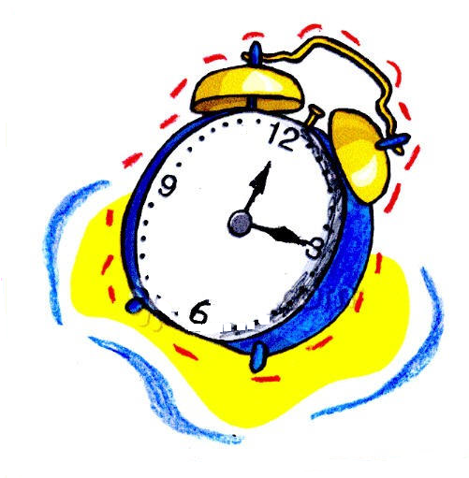

Choreographed by: Harlan Curtis – July 1, 2009
E-Mail: hccurtis@roadrunner.com
Diamond Bar, California, USA
Description: 32 count, 4 wall, Beginner / Intermediate Line Dance
Music: “15 Minutes” by Rodney Atkins
East Coast Swing Rhythm (132 BPM)
CD Album: “It’s America”, CD Label: Curb Records, Released March 31, 2009
Music is available on the artist’s web site and iTunes

Wait for the beginning verse to finish and then begin the dance on the word “SMOKIN”

Counts Step Descriptions
ROCK RIGHT, RECOVER LEFT, CROSS AND CROSS, STEP LEFT, 1/4 TURN RIGHT,
1/4 TURN RIGHT INTO A LEFT SIDE SHUFFLE
  - Rock right to right side, recover on left
3&4 Cross right over left, step left, cross right over left
  - Step left to left side, step right 1/4 right (3:00)
7&8 Step left 1/4 turn right stepping left to side, step right to side, step left to side (WOL) (6:00)

ROCK RIGHT, RECOVER LEFT, CROSS AND CROSS, STEP LEFT, 1/4 TURN RIGHT,
1/4 TURN RIGHT INTO A LEFT SIDE SHUFFLE
  - Rock right to right side, recover on left
3&4 Cross right over left, step left, cross right over left
5-6 Step left to left side, step right 1/4 right (9:00)
7&8 Step left 1/4 turn right stepping left to side, step right to side, step left to side (WOL) (12:00)

STEP FORWARD, TOUCH TOE BEHIND, STEP, KICK , COASTER STEP,
SHUFFLE FORWARD
1-2 Step forward on right, touch left toe behind
3-4 Step left in place, kick right forward
5&6 Step back right, step left beside right, step forward right
7&8 Step forward left, close right beside left, step forward left (12:00)

ROCK, RECOVER, 1/4 TURN RIGHT INTO RIGHT SIDE SHUFFLE, CROSS ROCK,
RECOVER, STEP, SLIDE
1-2 Rock forward on right, recover on left
3&4 1/4 turn right stepping right to side, close left next to right, step right to side (3:00)
5-6 Cross left over right, recover on right
7-8 Step left to side, slide right next to left (WOL)

Repeat

