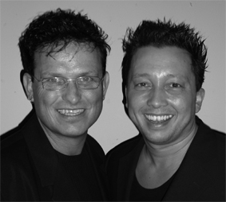
Dreams

Choreographers : Wil Bos and Roy Verdonk (sept 2009)
Level : Easy intermediate
Dance : 32 counts + 1 restart in wall 4
Music : Jody Bernal - Dreams ( CD - TMF Hitzone 17, and more)
Intro : 24 counts

Rock, Recover, ½ Turn Shuffle, Rocking Chair, Heel, Close, Cross
1-2 Rock right forward, Recover
3&4 ¼ turn right step right to right side, Close left next to right, ¼ turn right step right forward
5&6& Rock left forward, Recover, Rock left back, Recover
7&8 Put left heel forward, Close left next to right, Cross right over left

¼ Turn Step Back, Side Step, Cross Shuffle, ½ Turn Cross Shuffle, ½ Turn Cross Shuffle
1-2 ¼ turn right step left back, Step right to right side
3&4 Cross left over right, Step right to right side, Cross left over right
5&6 ½ turn right cross right over left, Step left to left side, Cross right over left
7&8 ½ turn left cross left over right, Step right to right side, Cross left over right

Rock, Recover, Cross, Side, Cross, Rock, Recover, Close, Rock, Recover
1-2 Rock right to right side, Recover
3&4 Cross right behind left, Step left to left side, Cross right over left
5-6 Rock left to left side, Recover
&7-8 Close left next to right, Rock right to right side, Recover*
*Note: Restart here wall 4.

Sailor Step, Sailor step ½ Turn, Point, Close, Point, Close, Heel, Close, Heel, Close
1&2 Cross right behind left, Step left to left side, Step right to right side
3&4 ¼ turn left cross left behind right, Step right next to left, ¼ turn left step left to left side
5&6 Point right toe to right side, Close right next to left, Point left toe to left side
&7&8& Close left next to right, Right heel forward, Close right next to left,
Left heel forward, Close left next to right

Start again and let the music touch your soul

