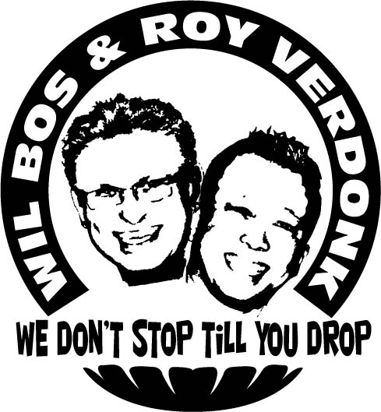
Don’t Cry For Me

Choreographer : Wil Bos en Roy Verdonk (june 2010)
Level : Easy intermediate
Dannce : 64 Counts, Wall: 2
Music : Andy Tielman and the Tielman brothers – Don’t Cry For Me
CD : Can’t Stop Loving You
Intro : 16 counts

Side, Cross Behind L, Side, Cross Over L, Side Rock R, Cross over R, Hold
1-2 Step right to right side, Cross left behind right,
3-4 Step right to right side, Cross left over right
5-6 Rock right to right side, Recover on left,
7-8 Cross right over left, Hold

¼ Turn R, ¼ Turn R., Cross Rock L, Recover R, Side, Close R, ¼ Turn L, Scuff R
1-2 ¼ Turn right step left back, ¼ turn right step right to right side,
3-4 Cross rock left over right, Recover on right
5-6 Step left to left side, Close right next to left,
7-8 ¼ turn left step left forward, Scuff right forward

Rock R, Recover L, ½ Turn R, Scuff L, ¼ Turn R. Touch R, ¼ Turn R., Touch L
1-2 Rock right forward, Recover on left
3-4 ½ turn right step right forward, Scuff left forward
5-6 ¼ Turn right step left to left side, Touch right next to left
7-8 ¼ Turn right step right to right side, Touch left next to right

Side, Close, ¼ Turn L, Scuff R, Rock R, Recover L, ½ Turn R., Scuff L
1-2 Step left to left side, Close right next to left,
3-4 ¼ Turn left step left forward, Scuff right forward
5-6 Rock right forward, Recover on left,
7-8 ½ turn right step right forward, Scuff left forward.

¼ Turn R. Touch R, ¼ Turn R., Touch L, Side, Close, ¼ Turn L., Scuff R
1-2 ¼ turn right step left to left side, Touch right next to left
3-4 ¼ turn right step right to right side, Touch left next to right
5-6 Step left to left side, Close right next to left
7-8 ¼ turn left step left forward, Scuff right forward

Step R, Pivot L, Step R, Hold, Full Turn R. Scuff R
1-2 Step right forward, ½ Turn left,
3-4 Step right forward, Hold
5-6 ½ Turn right step left back, ½ turn right step right forward,
7-8 Step left forward, Scuff right next to left forward.

Cross R, Step L back, Step R back, Cross Lock L. Coaster Step L, Scuff R
1-2 Cross right over left, Step left back,
3-4 Step left back , Cross left over right
5-6 Step right back, Close left next to right,
7-8 Step right forward, Scuff left forward.

Rock L, Recover R, ½ Turn left, Scuff L, 1/8 Turn left (x2) with hip movements
1-2 Rock left forward, Recover on right
3-4 ½ turn left step left forward, Scuff right forward
5-6 Step right forward, 1/8 turn left (transfer weight on left with hip movements)
7-8 Step right forward, 1/8 turn left (transfer weight on left with hip movements)

Start again

