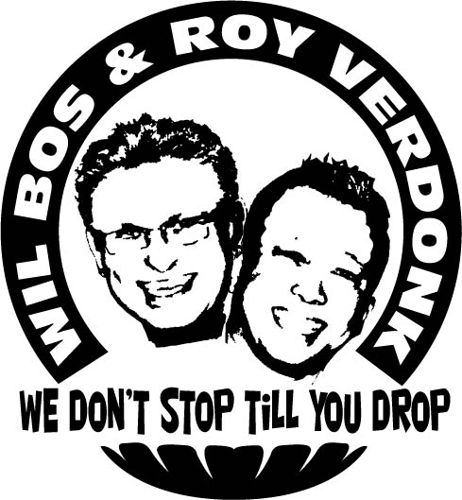
Da Doo Run Run

Choreographers : Roy Verdonk & Wil Bos (May 2010)
Level : Intermediate

Dance : 2 walls Phrased – A A B A B B B

Counts : Part A – 72 counts, Part B – 32 counts
Music : Da Doo Run Run – Shaun Cassidy

Intro : 32 counts, start on vocals

Part A

Kick Ball Step R (x2), Rock R Forward, Recover L, ½ Turn Shuffle R.
1&2 Kick right forward, Step on ball of right next to left, Step left forward
3&4 Kick right forward, Step on ball of right next to left, Step left forward
5-6 Rock right forward, Recover on left
7&8 ¼ turn right step right to right side, Close left next to right, ¼ turn right step right forward (6.00)

Rock L Forward, Recover R, Coaster Step L, Rock R Forward, Recover L, ¼ Turn R Shuffle R.
1-2 Rock left forward, Recover on right
3&4 Step back on left, Close right next to left, Step left forward
5-6 Rock right forward, Recover on left
7&8 ¼ turn right step right to right side, Close left next to right, Step right to right side (9:00)

Cross L over R, Monterey ½ Turn R, Rock L over R, Recover R, Side Shuffle L
1-2 Cross left over right, Point right to right
3-4 ½ turn right on ball of left and close right next to left, point left to left
5-6 Cross Rock left over right, Recover on right.
7&8 Step left to left side, Close right next to left, Step left to left side (3.00)

Kick R forward, Kick R to Right, Sailor R, Kick L forward, Kick L to Left, Sailor L with ¼ turn Left
1-2 Kick right forward, Kick right to right side
3&4 Cross right behind left, Step left to left side, Step right to right side
5-6 Kick left forward, Kick left to left side
7&8 On ball of right ¼ turn left and cross left behind right, Step right to right side, Step left to left side (12.00)

Ball R, Step L, Hold, Cross Rock R, Recover L, Side Shuffle R, Cross Rock L, Recover R
&1-2 Step on ball of right next to left, Step left to left side, Hold
3-4 Cross Rock right over left, Recover on left
5&6 Step right to right side, Close left next to right, Step right to right side
7-8 Cross Rock left over right, Recover on right (12.00)

Ball L, Cross R, Hold, Rock L to Left Side, Recover R, Cross Shuffle L, ¼ Turn L, ¼ Turn L
&1-2 Step on ball of left next to right, Cross right over left, Hold
3-4 Rock left to left side, Recover on right
5&6 Cross left over right, Step right to right side, Cross left over right
7-8 ¼ turn left step back on right, ¼ turn left step left to left side (6.00)

Ball R, Step L, Hold, Rock R over L, Recover L, Side Shuffle ¼ turn R, ½ Turn Shuffle R
&1-2 Step on ball of right next to left, Step left to left side, Hold
3-4 Cross Rock right over left, Recover on left
5&6 Step right to right side, Close left next to right, ¼ turn right step right forward
7&8 ¼ turn right step left to left side, Close right next to left, ¼ turn right step back on left (6.00)

¼ Turn Right step R, Cross L over R, Step R to Right side, Touch L, Ball L, Cross R, Step L, Behind Side Cross
1-2 ¼ right step right to right side, Cross left over right
3-4 Step right to right side, Touch left toes to left diagonal
&5-6 Step left next to right, Cross right over left, Step left to left side
7&8 Cross right behind left, Step left to left side, Cross right over left (6.00)

Rock L, Recover R, Cross L Behind R, R to Right Side, Step Forward L, Pivot Turn L (x2)
1-2 Rock left to left side, Recover on right
3&4 Cross left behind right, Step right to right side, Step left forward
5-6 Step forward on right, ½ turn left take weight on left
7-8 Step forward on right, ½ turn left take weight on left (6.00)

Part B

R Shuffle ¼ turn L, L Shuffle ¼ Turn L, R Shuffle ¼ Turn L, Side Shuffle L.
1&2 Step right to right side, Close left next to right, ¼ turn left step right back
3&4 Step left to left side, Close right next to left, ¼ turn left step left forward
5&6 Step right to right side, Close left next to right, ¼ turn left step right back
7&8 Step left to left side, Close right next to left, Step left to left side (3.00)

Cross R, Side L, Cross Behind R, Point L, Cross L, Side R, Cross L Behind, Point R
1-2 Cross right over left, Step left to left side
3-4 Cross right behind left, Point left to left
5-6 Cross left over right, Step right to right side
7-8 Cross left behind right, Point right to right (3.00)

Cross R, Step L, Cross R Behind, Step ¼ Turn L, Step R, ¾ Turn L, Step R, Cross L Behind
1-2-3-4 Cross right over left, Step left to left side, Cross right behind left, ¼ turn left step left forward
5-6-7-8 Step right forward, 3/4 turn left, Step right to right side, Cross left behind right (3.00)

Step ¼ Turn R, Step L, ¾ Turn R, Step L, Cross R Behind, ¼ Turn L, Step R, Pivot ½ L
1-2-3-4 ¼ turn right step right forward, Step left forward, 3/4 turn right, Step left to left side
5-6-7-8 Cross right behind left, ¼ turn left step left forward, Step right forward, ½ turn left weight on left (6.00)

Start again and always keep smiling

