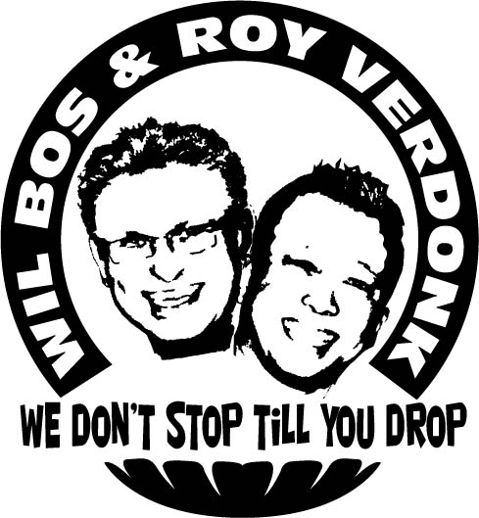
Carousel

Choreographers : Wil Bos & Roy Verdonk

Level : Intermediate

Dance : 64 counts, 2 walls, 1 Restart in wall 3

Music : Carousel - Ilse de Lange, CD: Next to me

Intro : 16 Counts

Step R. 1/8 Turn Left, Cross Behind, ¼ Turn R, ¼ Turn R., Cross Behind, ¼ Turn L. Step Forward R., Pivot L.
1-2 1/8 turn left step right to right diagonal, Cross left behind right (step towards 01:30)
3-4 ¼ turn right step right forward, ¼ turn right step left to left side
5-6 Cross right behind left, ¼ turn left step left forward
7-8 Step right forward, ½ turn left (07:30)

Step R., Hold, ½ Turn R. (x2), Left Toe Strut, Right Toe Strut
1-2 Step right forward, Hold
3-4 ½ turn right step back on left, ½ turn right step right forward
5-6 Touch left toes forward, Drop left heel
7-8 Touch right toes forward, Drop right heel

¼ Turn R., Cross Behind, ¼ Turn L., ¼ Turn L., Cross Behind, ¼ Turn R., Step Forward L., Pivot R.
1-2 ¼ turn right step left to left side, Cross right behind left
3-4 ¼ turn left step left forward, ¼ turn left step right to right side
5-6 Cross left behind right, ¼ turn right step right forward
7-8 Step left forward, ½ turn right (01:30)

Step L., Hold, ½ Turn Left (x2), Right Toe Strut, Left Toe Strut
1-2 Step left forward, Hold
3-4 ½ turn left step back on right, ½ turn left step left forward
5-6 Touch right toes forward, Drop right heel
7-8 Touch left toes forward, Drop left heel

Step Forward R. Diagonal, Touch L., Step L., Touch R., Step back R. Diagonal., Touch L., Step L., Touch R.
1-2 Step right forward to right diagonal, Touch left next to right & Clap
3-4 Step left to left side, Touch right next to left & Clap (12:00)
5-6 Step right back to right diagonal., Touch left next to right & Clap
7-8 Step left to left side, Touch right next to left & Clap ***

Step R., Cross L. Behind, ¼ Turn Right, Step Forward, Pivot R., ¼ Turn Right, Cross R. Behind, ¼ Turn L.
1-2 Step right to right side, Cross left behind right
3-4 ¼ Turn right step right forward, Step left forward
5-6 ½ turn right, ¼ turn right step left to left side
7-8 Cross right behind left, ¼ turn left step left forward (09:00)

Right Toe Strut, Rock, Recover, Step L. back, ¼ Turn Right, Cross, Hold
1-2 Touch right toes forward, Drop right heel
3-4 Rock left forward, Recover
5-6 Step back on left, ¼ right step right to right side (12:00)
7-8 Cross left over right, Hold

Side Rock, Recover, Cross, Hold, ¼ Turn right (x2), Step Forward, Hold
1-2 Rock right to right side, Recover
3-4 Cross right over left, Hold
5-6 ¼ turn right step back on left, ¼ turn right step right to right side (06:00)
7-8 Step left forward, Hold

*** Restart
Wall 3, restart the dance after count 40.

Start again smile ☺ and have fun

