COUNTRY BOYS ROLL
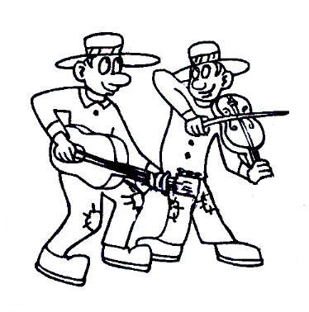
Choreographed by Harlan Curtis, February 2, 2009
E-Mail: hccurtis@roadrunner.com Diamond Bar, California, USA
Description: 32 count, 4 wall, beginner / intermediate line dance
Music: “That’s How Country Boys Roll” by Billy Currington (120 BPM)
CD Album: “Little Bit Of Everything”, Mercury Records, # B0009550-02, Oct. 2008
Music is available at Artist’s website, iTunes, eMusic, & Target Stores
Start dancing on lyrics (16 counts in)

Counts Step Descriptions
ROCK FORWARD RIGHT, RECOVER LEFT, AND CROSS, HOLD AND CLAP,
ROCK RIGHT, RECOVER LEFT, CROSS AND CROSS
1 - 2 Rock forward on right, recover on left
& 3 - 4 Step right slightly back and cross left over right, hold & clap
5 - 6 Rock right to right, recover on left
7 & 8 Cross right over left, step left to side, cross right over left (12:00)

ROCK LEFT, RECOVER RIGHT, SHUFFLE FORWARD, ROCK FORWARD RIGHT,
RECOVER LEFT, 1/2 TURN RIGHT SHUFFLE FORWARD
1 - 2 Rock left to left side, recover on right
3 & 4 Step forward left, close right beside left, step forward left
5 - 6 Rock forward on right, recover on left
7 & 8 Shuffle step forward making 1/2 turn right, stepping right, left, right (6:00)

LEFT SIDE ROCK, RECOVER RIGHT, BEHIND & CROSS, RIGHT SIDE ROCK,
RECOVER LEFT, BEHIND & CROSS
1 - 2 Rock left to left side, recover on right
3 & 4 Cross left behind right, step right slightly right, cross left over right
5 - 6 Rock right to right side, recover on left
7 & 8 Cross right behind left, step left slightly left, cross right over left (6:00)

WIZARD STEPS 2X, ROCK FORWARD LEFT, RECOVER RIGHT,
TRIPLE 3/4 TURN LEFT
1 - 2 & Step left forward, lock right behind left, & step left forward
3 - 4 & Step right forward, lock left behind right, & step right forward
5 - 6 Rock forward on left, recover on right
7 & 8 Triple step 3/4 turn left in place stepping left, right, left (9:00)

REPEAT

