COOLER THAN ME 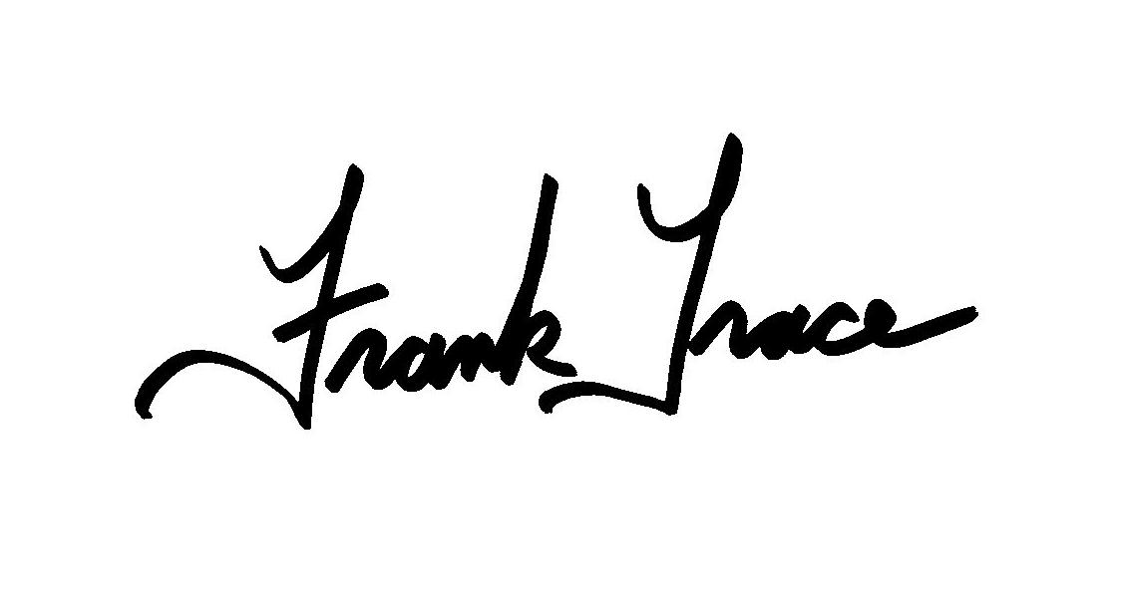
Choreographed by Frank Trace
32 count, 4 wall Beginner Line Dance
Music: “Cooler Than Me” by Mike Posner
Start the dance on the heavy beat, 34 seconds into the song.

HEEL, TOE, SIDE STEP RIGHT, DRAG TOUCH
HEEL, TOE, SIDE STEP LEFT, DRAG TOUCH
1-2 Touch R heel forward, touch R toe next to L
3-4 Large side step to right with R, drag touch L next to R
5-6 Touch L heel forward, touch L toe next to R
7-8 Large side step to left with L, drag touch R next to L

ROCKING CHAIR, HIP SWIVELS 1/4 TURN LEFT
1-4 Rock R forward, recover onto L, rock R back, recover onto L
5-8 Rolls hips R, L, R, L turning 1/4 left (this could be a 1/4 paddle turn)
weight ends on left (9:00)

WALK FORWARD, KICK FORWARD, TURN HALF LEFT,
WALK FORWARD, KICK DIAGONALLY RIGHT
1-4 Walk forward R, L, R, kick L diagonally left
5-8 Turn 1/2 left and step on L, walk forward R, L, kick R diagonally right (3:00)

JAZZ BOX WITH CROSS OVER, STEP BACK DIAGONAL RIGHT, DRAG TOUCH, STEP BACK DIAGONAL LEFT, DRAG TOUCH
1-4 Cross step R over L, step L back, step R to R side, step L over R
5-6 Step R back diagonally right (turn body diagonally right), drag touch L next to R
7-8 Step L back diagonally left (turn body diagonally left), drag touch R next to L
REPEAT

