Come A Little Closer

Description: 24 count, 4 wall, Beginner line dance
Music: Make Love To Me by Anne Murray
Begin On The 16th Count
Choreographed by Jackie Lincoln in Virginia Beach

LOCK STEP FORWARD RIGHT, LOCK STEP FORWARD LEFT, PADDLE 1/8 TURN LEFT TWICE
1&2 Step R foot forward, cross L foot behind right, step R foot forward
3&4 Step L foot forward, cross R foot behind left, step L foot forward
5-6 Tap R toe forward and push to the left while pivoting 1/8 turn on L foot
7-8 Tap R toe forward and push to the left while pivoting 1/8 turn on L foot (9:00)
SHUFFLE FORWARD RIGHT, SHUFFLE ½ TURN RIGHT, ROCKING CHAIR
9&10 Step R foot forward, step L foot beside right, step R foot forward
11&12 Step L foot to left side while turning ¼ to right, step R foot beside right, step L back while turning ¼ to right (3:00)
13-14 Rock R foot back, recover on L foot
15-16 Rock R foot forward, recover on L foot
COASTER STEP, SHUFFLE FORWARD, TOUCH, CROSS, TOUCH, CROSS
17&18 Step R foot back, step L foot beside right, step R foot forward
19&20 Step L foot forward, step R foot beside left, step L foot forward
21-22 Touch right toe to right side, step right foot across left foot
23-24 Touch left toe to left side, step left foot across right foot
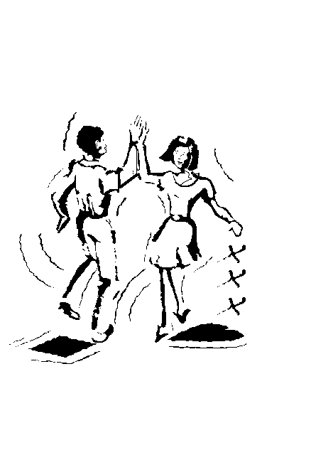
REPEAT

