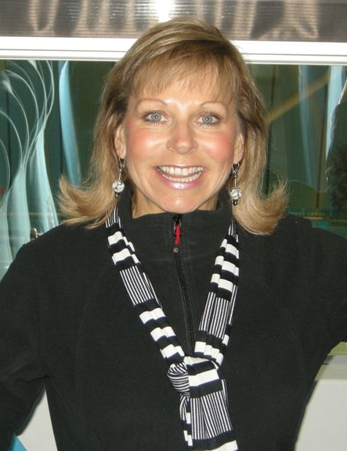
CHASIN’ RODEO FIRST STEPS

Choreographer: Alison Johnstone (Perth WA ex Scotland)
Prepared By: Alison Johnstone (Grapevine) 01/07/2009
Music:”Chasin’ Rodeo” Troy Cassar-Daley (I love This Place album & I Tunes)
Start: On the lyrics
Walls: 4 wall
Level: Beginners
Tags: 1 very easy restart after 1st 16 counts on 3rd wall facing 6.00
Contact: alisonjo@westnet.com.au +61 404445076

WALK, WALK, WALK, KICK & CLAP, WALK BACK, BACK, BACK, TAP & CLAP (12.00)
1-2 Walk fwd Left, Walk fwd Right
3-4 Walk fwd Left, Kick Right & Clap
5-6 Walk back Right, Walk Back Left,
7-8 Walk Back Right, Tap Left into Right

GRAPEVINE LEFT ¼ TURN LEFT, GRAPEVINE RIGHT ¼ TURN RIGHT (12.00)
9-10 Step Left to side, Step Right behind Left
11-12 Step Left to side ¼ turning over Left shoulder, Tap Right into Left
13-14 Step Right to side, Step Left behind Right,
15-16 Step Right to side ¼ turning over Right. Tap Left into Right
RESTART: Here during wall 3 facing (6.00). Very easily heard in the music.

ROCK, RECOVER, COASTER STEP, ROCK, RECOVER COASTER STEP (12.00)
17-18 Rock fwd on Left, Recover on Right
19&20 Step back onto Left, Step Right into Left, Step fwd onto Left
21-22 Rock fwd on Right, Recover on Left
23&24 Step back onto Right, Step Left into Right, Step fwd on Right

ROCK, RECOVER, CHASSE ¼ TURN LEFT, JAZZ BOX (9.00)
25-26 Rock fwd on Left, Recover on Right
27&28 Step Left to side, Step Right into Left, Step Left to Left ¼ turning over Left
29- 30 Step Right Across Left, Step back onto Left
31-32 Step Right to side, Tap Left into Right

NB When beginners are dancing on a split floor with the intermediate dance (Chasin’ Rodeo) everyone will be facing 6.00 after the 2nd wall of beginners and shall dance the 1st 16 steps together (these are the tag on the main dance. Should be great for the beginners ☺ ENJOY!!!!!

Well here it is …………. a definite beginners YEEHAA dance☺
The music rocks and is from Troy Cassar-Daley’s new album “I love this place”.
Only one single released thus far but it wouldn’t surprise me if this was a future single.

Intermediate Dance Available - Chasin Rodeo (Alison Johnstone)

