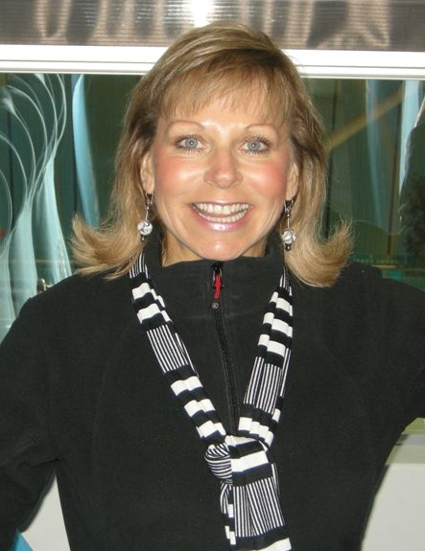
CHASIN’ RODEO

Choreographer: Alison Johnstone (Perth WA ex Scotland)
Prepared By: Alison Johnstone (Grapevine) 01/07/2009
Music:”Chasin’ Rodeo” Troy Cassar-Daley (I love This Place album & I Tunes)
Start: On the lyrics
Walls: 2 wall
Level: Intermediate
Tags: 1 very easy Tag at end of 1st wall facing 6.00
Contact: alisonjo@westnet.com.au +61 404445076

WALK, WALK, SHUFFLE, PIVOT ¼, CROSS SHUFFLE (9.00)
1-2 Walk fwd Left, Walk fwd Right
3&4 Step Left forward, Step Right into left, Step left forward
5-6 Step forward onto Right, Pivot ¼ turn over Left
7&8 Cross Right over Left, Step Left to Left, Cross Right over Left

FULL SPIN, CHASSE, BACK ROCK, RECOVER, KICK BALL CHANGE (9.00)
9-10 Step Left to side turning ½ over Right, Step Right fwd turning ½ over Right
11&12 Step Left to side, Step Right into Left, Step Left to side
13-14 Rock back onto Right, Recover onto Left
15&16 Kick Right fwd, Step ball of Right beside Right, Step onto Left
Alternative without full spin for counts 9-10 Step Left to side, Cross Right behind Left,

ROCK RECOVER, COASTER STEP, ROCK RECOVER, COASTER STEP (9.00)
17-18 Rock Right to side, Recover on left
19&20 Step back onto Right, Step Left into Right, Step fwd on Right
21-22 Rock Left to side, Recover on Right
23&24 Step back onto Left, Step Right into Left, Step fwd onto Left

WALK, WALK, SHUFFLE, KICK, CROSS, UNWIND ½, HOLD CLAP (3.00)
25-26 Walk fwd Right, Walk fwd Left
27&28 Step Right forward, Step Left into Right, Step Right forward
29-30 Kick Left fwd, Cross Left Over Right
31-32 Unwind ½ over Right taking weight onto Left, Hold and Clap

KICK BALL CHANGE, ¼ TURN KICK BALL CHANGE, SHUFFLE, SHUFFLE (6.00)
33&34 Kick Right fwd, Step ball of Right beside Right, Step onto Left

&35&36 ¼ turn Right over Right (&) Kick Right fwd, Step ball of Right beside Right, Step onto Left
37&38 Step Right forward, Step Left into Right, Step Right forward
39&40 Step Left forward, Step Right into left, Step left forward

PIVOT TURN ½, SHUFFLE, PIVOT TURN ½, SHUFFLE (6.00)
41-42 Step forward onto Right, Pivot ½ turn over Left

43&44 Step Right forward, Step Left into Right, Step Right forward

45-46 Step forward onto Left, Pivot ½ turn over Right

47& 48 Step Left forward, Step Right into left, Step left forward

JAZZ BOX ½ TURN, APPLEJACKS X 4 (12.00)
49-50 Cross Right Over left, Step Back Onto Left ¼ turning over Right

51-52 Step Right to side ¼ turning over Right, Step left to side (feet hip distance apart)

&53&54& Applejack heel toe to Left (&), Return Center, Applejack heel toe to Right (&), Return Center

&55&56 Applejack heel toe to Left (&), Return Center, Applejack heel toe to Right (&), Return Center

& Small hitch Right (will happen naturally preparing for Shuffle)
Alternative for Applejacks counts=Heel Digs
53-54 Dig Right Heel fwd, Return,
55-56 Dig Left Heel fwd, Return,
Or Heel switches Right, Left, Right, Left

SHUFFLE, SCUFF HITCH STEP, HITCH RIGHT (&), SMALL RT & RT & RT & RT RUN FWD
WHILST SPINNING THE LASSOO WITH ARM RIGHT , HITCH LEFT ½ TURN (&)(6.00)
57&58 Step Right forward, Step Left into Right, Step Right forward

59&60 Scuff Left foot fwd past Right, Scoot fwd on Right hitching Left leg, Step fwd onto Left

&61&62 Hitch Right leg (&), Small Step fwd Right, Step Left into Right (&), Small step fwd Right
&63&64 Step Left into Right (&), Small step fwd Right, Step Left into Right (&), Small step fwd Right
& Hitch Left leg turning on ball of right ½ Left ready to restart dance to new wall (walk, walk)

TAG At end of 1st wall (facing 6.00) Very easy tag, dance full 16 counts below then start the dance still facing 6.00

  - Walk fwd Left, Right, Left, Kick Right fwd and Clap
  - Walk back Right, Left, Right, Tap Left into Right and Clap
9-12 Rolling Vine Left with a Clap
  - Rolling Vine Right with a Clap
Rolling Left Vine description
(Step Left to side ¼ over Left, Step Right to side ½ over Left, Step Left to Side ¼ over Left,
Tap Right into Left with a Clap)
Rolling Vine Right is as above on Right to the Right
**Normal Grapevines if not spinning**

Then dance ends facing front after executing the 2nd Kick Ball Change (36)

Well here it is …………. a definite YEEHAA dance☺
The music rocks and is from Troy Cassar-Daley’s new album “I love this place”.
Only one single released thus far but it wouldn’t surprise me if this was a future single.

Beginners Dance available - Chasin Rodeo First Steps (Alison Johnstone)

