BMT (aka SS Rumba)
Choreographed by Forty Arroyo (1/10)
32ct, 4 wall, Beginner Line Dance - Dedicated to The Sturbridge Senior Line Dancers
Suggested Music: It’s Now or Never by John Dean – It’s Now or Never by Elvis Presley
Inspired by the lovely Intermediate line dance “Be Mine Tonight” choreographed by Peter Metelnick & Alison Biggs

SIDE, HOLD, ROCK, RECOVER, SIDE, HOLD, ROCK RECOVER (ends at 12 o’clock)
1-4 Step side R, Hold, Cross rock L over R, Step R in place
5-8 Step side L, Hold, Cross rock R over L, Step L in place

STEP, HOLD, BACKWARD WEAVE (ends at 12 o’clock)
1-4 Step back on R, Hold, Cross L over R, Step back on R
5-8 Step back on L, Cross R over L, Step back on L, Step back on R

FORWARD RUMBA, LEFT AND RIGHT (ends at 12 o’clock)
1-4 Step forward on L, Hold, Step side R, Step L next to R
5-8 Step forward on R, Hold, Step side L, Step R next to L

STEP ¼ TURN, HOLD, ROCK ,RECOVER, CROSS, HOLD, STEP, TOUCH (ends at 9 o’clock)
1-2 Starting a ¼ left – Step L slightly forward pointing toes to L, Hold
3-4 Completing the ¼ turn (above) – Rock R to side, Step L in place
5-8 Cross R over L, Hold, Step L to side, Touch R next to L
Note: for a little styling (on count 8 of this section) drag R toward L keeping your weight on L.

ENJOY!! TRY IT CONTRA FOR ADDED FUN!!
Try it to your favorite Rumba track.
Dance while you can!!
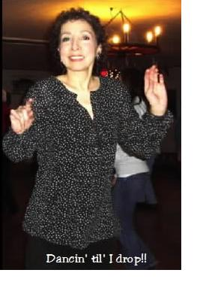
Forty Arroyo
Dancin’ with Funk, Spirit and Spunk

