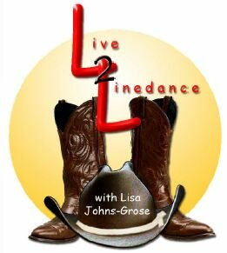

AMERICAN TRADITION
CHOREOGHRAPHER: LISA M. JOHNS-GROSE htmonalisa@aol.com
DESCRIPTION: 32 CT. 4-WALL BEGINNER
MUSIC: IT’S AMERICA BY: RODNEY ATKINS

VINE RIGHT-TOUCH LEFT

1-4 Step right to right, step left behind right, step right to right, touch left next to right

VINE LEFT W/ ¼ TURN LEFT

5-8 Step left to left, step right behind left, step left ¼ turn left, touch right next to left

WALK FWD R-L-R KICK L

1-4 Walk forward on right, then left, then right, kick left

WALK BACK L-R-L TOUCH R

5-8 Walk back left, back right, back left, touch right

WALK ONE FULL CIRCLE LEFT W/ BRUSHES

1-8 Beginning one full circle left, step forward with right, brush left next to right, step forward with left, brush right next to left, step right, brush left, step left brush right (completing one full turn left)

RIGHT ROCKING CHAIR- STEP FWD RIGHT – TOGETHER LEFT – BUTTERFLY

1-4 Rock forward on right, rock back on left, rock back on right, rock forward on left (left foot stays in place during these 4 counts)
5-8 Step right forward , step left together, splits heels apart, bring back together

BEGIN AGAIN ☺

