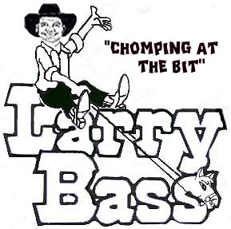

Another Saturday Night
Choreographed 9-17-10 by Larry Bass

Inquiries: (Larry Bass PH/FAX 904-737-2144); E-mail: lbass6622@comcast.net
6405 Starling Ave. Jacksonville, Fl. 32216

Description: 4 wall, 32 count intermediate line dance
Music: “Another Saturday Night” by Sam Cooke
“Saturday Night” by Sam Millar (An easy 4 count tag after the 9th wall, you will be facing the 3:00 wall)
Amazon Download:
http://www.amazon.com/Another-SaturdayNight/dp/B0016CTRUU/ref=sr_1_1?ie=UTF8&qid=1283697049&sr=1-1
http://www.amazon.com/s/ref=nb_sb_ss_c_1_10?url=search-alias%3Ddigital-music&field-keywords=sam+millar&sprefix=sam+millar

CROSSOVER ROCK STEP, SIDE STEP, SLIDE & TOUCH; STEP ¼ TURN, TOUCH, TRIPLE STEP FORWARD
1-2 Step Right across Left; Rock back onto Left
3-4 Step Right a long step to right side; Slide & touch Left to right
5-6 Step Left to left side; Turn ¼ turn right & touch Right in front of Left
7&8 Triple step forward Right, Left, Right

ROCK STEP, ½ TURN TRIPLE STEP; STEP ½ PIVOT, STEP ½ PIVOT
1-2 Step Left forward; Rock back onto Right
3&4 Triple step Left, Right, Left while turning ½ turn left
5-6 Step Right forward; Pivot ½ turn left onto Left
7-8 Step Right forward; Pivot ½ turn left onto Left

TRIPLE STEP, ROCK STEP, TRIPLE STEP, BEHIND SIDE
1&2 Triple step Right, Left, Right to right side
3-4 Step Left back; Rock forward onto Right
5&6 Triple step Left, Right, Left to left side
7-8 Step Right behind Left; Step Left to left side

CROSSOVER TRIPLE STEP, SIDE ROCK ¼ TURN, FORWARD TRIPLE STEP; ¾ TURN FORWARD ROLL
1&2 Step Right across Left; Step Left to left side, Step Right across Left
3-4 Step Left to left side; Rock right onto Right while turning ¼ turn Right
5&6 Triple step forward Left, Right, Left
7-8 Rolling forward, turn ½ turn left stepping onto Right; Turn ¼ turn left & step Left to left side

START OVER

Tag for Saturday Night by Sam Millar:
CROSSOVER ROCK STEP; SIDE ROCK STEP
1-2 Step Right across Left; Rock back onto Left
3-4 Step Right to right side; Rock left onto Left

START OVER

