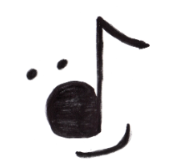
Jingle Hop
Count: 32
Wall: 2
Level: Upper beginner/ improver
Choreographer: Helen A. Walker, December 2010
Dancer29045@yahoo.com
Music: Jingle Bell Rock, The Brian Setzer orchestra.
Cadillac Baby, Colin James.
Side rock and kick
1 2 Rock right foot to the right side and recover weight onto left foot.
3 4 Kick right foot forward a small low kick twice.
5 6 Rock right foot to the right side and recover weight onto left foot.
7 8 Kick right foot forward a small low kick twice.

Step ½ turn pivots, coaster step
1 Step right foot back as you make ½ turn right (6:00)
2 Hitch left foot and pivot on the right foot turning continuing turn another 1/2 to the right (12:00)
3 Step left down
4 Kick right foot forward a small low kick
5 Step right foot back
6 bring left foot to right
7 Step right foot forward
8 Step left foot forward to right

Rock and cross steps
1 Step right foot across in front of left
2 Step left foot to left side
3 Rock weight onto right foot
4 Step left foot across in front of right
5 Step right foot to right side
6 Rock weight on to left foot
7 Step right foot across in front of left
8 Step left foot to right foot

Walks to make a slow ½ right turn with attitude!
1 Step right foot ¼ turn to right (3:00)
2 Hold
3 Step left foot forward
4 Hold
5 Step right foot ¼ turn to right (6:00)
6 Hold
7 Step left foot forward
8 Hold

